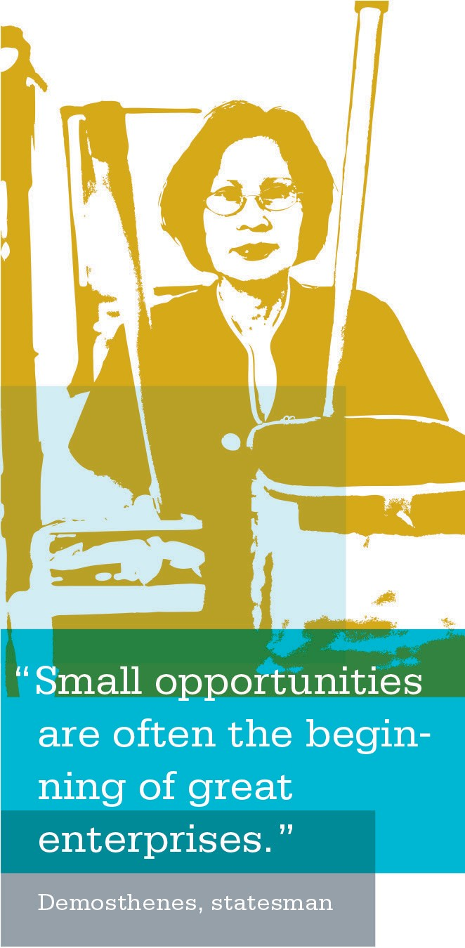
Additional References and Where to Find Them
LMP Vision: Reaffirmation & Understandings (2002)
This document is a summary of two national retreats with leaders from Kaiser Permanente and the Coalition of Kaiser Permanente Unions, who met to complete a pivotal re-examination of the future envisioned under the LMP. Of particular interest is the section on making decisions, which clarifies levels of involvement based on interest
and expertise.
LMPartnership.org/contracts/agreements/docs/reaffirmation.pdf

2005 National Bargaining Agreement
The 2005 National Bargaining Agreement can be found on the national OLMP website:
LMPartnership.org/contracts/agreements/docs/ 2005_national_agreement_agreement.pdf

National Labor Management Partnership Website
The national LMP website is a resource for information on the history, agreements, resources and tools of the LMP and provides an assortment of communication materials, from fliers to Hank to local updates.
LMPartnership.org/index.html

Jump Start Guide for Workplace Safety
This is an easy-to-use guide designed to expand the Partnership to the work-unit level and use the partnership approach to reduce workplace injuries. In addition to the basics for establishing a WPS team, it includes informa- tion on risk identification and analysis, root cause analysis and hazard control strategies. Contact your local WPS Committee or co-leads for a copy of this guide or refer to the link below.
xnet.kp.org/hr/ca/lmp/wps_jumpstart.pdf

Issue Resolution and Corrective Action User’s Guide and Toolkit
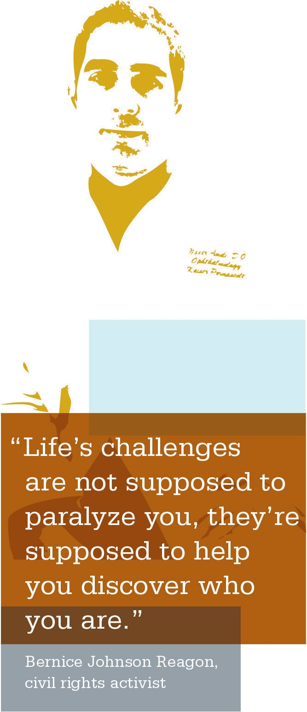
This guide provides policy and procedure guidance for consistent application of issue resolution and corrective action, in accordance with the philosophy and intent of the procedure. It provides an overview of the process and examples of forms.
xnet.kp.org/hr/ca/lmp/IRandCA_userguide_toolkit.pdf

UBT Information Tools
LMPartnership.org/ubt

RIM—Plan, Do, Study, Act
LMPartnership.org/ubt/pdsa/index.html

Performance Improvement
http://kpnet.kp.org/qrrm/

LMP Contacts
- LMP and Union Coalition Staff
- LMP Strategy Group
- Regional Team Leads and Members
- Local Unions
- Local Training Contacts
- KP Internal Phonebook (KP intranet)
LMPartnership.org/about/contacts/index.html

Glossary of Terms

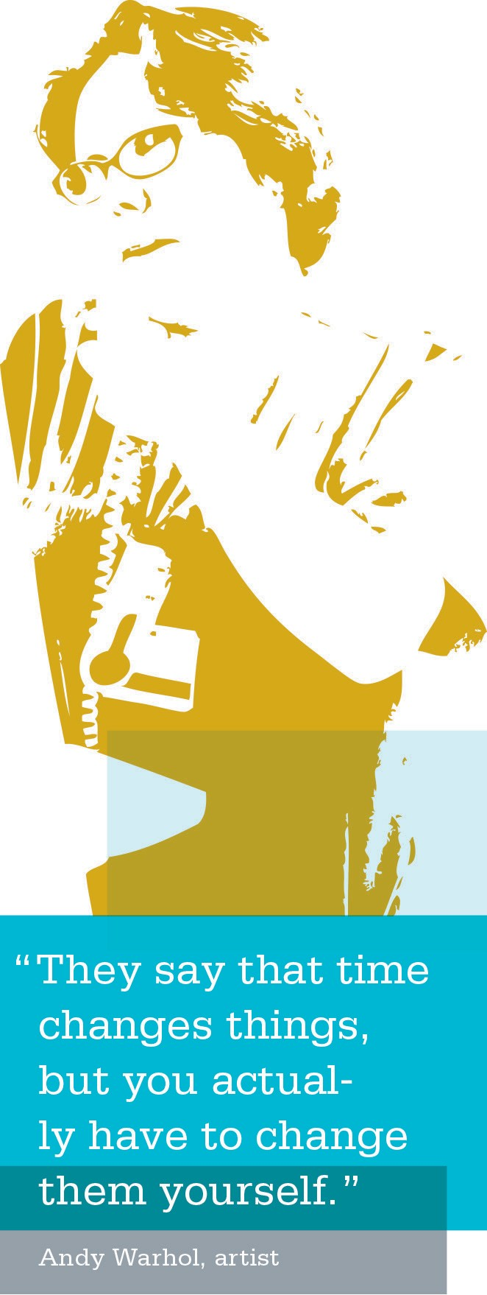
Baseline—First set of measurements before testing a change. Provides a marker to show which areas are doing well and which need improvements.

Co-lead (of department or unit-based team)—The co-leads work directly with the frontline teams to implement improve- ments during the 90–120 day cycle for implementation and the 90-day cycle for sustainability.

Continuous Improvement—Represents a future state where employees come to the workplace every day thinking about how they can improve their work.

Control Group—Unchanged variable (clinic or region) that can be used to compare progress with to see whether
improvement is due to change or something else unrelated.

Denominator—Second or bottom number in the ratio. Some tests of change may want this number to decrease to show improvement.
Example: We want to improve the number of female patients
screened for cervical cancer. Women with hysterectomies should not be included. Including them is understating our true performance.

Metrics (or Measure)—Number linked to some aspect of performance. Most metrics are expressed as a ratio or percentage of one number to another.
Example: We give our members a survey to find out how many are satisfied with their primary care visits. One hundred members fill out the survey and 80 of them report being satisfied. That means that 80 percent (i.e., 80 out of the 100) are satisfied.

Numerator—First or top number in a ratio. Some tests of change may want to see this number increase to show improvement.
Example: We would want the number of patients, 80, who report they are satisfied to go up.

Operational Leader—Organizational leaders who are responsible for managing operations. Can include directors, assistant directors, managers, assistant managers and supervisors.

PDSA Cycle (Created by the Institute for Healthcare Improvement)—A structured trial of a process change. Drawn from the Shewhart cycle, this effort includes:
- Plan—a specific planning phase;
- Do—a time to try the change and observe what happens;
- Study—an analysis of the results of the trial; and
- Act—devising next steps based on the analysis.
This PDSA cycle will naturally lead to the plan component of a subsequent cycle.

Performance Improvement Institute—KP Program Offices improvement program that includes a curriculum, training and limited support across the regions.

Performance Improvement (KP definition)—Organizational change where UBTs and other high-performing teams measure the current level of performance of their work, then generate ideas for modifying their work to achieve better service, quality or efficiency to benefit all of those involved in the process (including staff, physicians and most importantly, our customers).

Rapid Improvement Model (RIM)—Based on the Institute for Healthcare Improvement’s model for improvement.
Emphasizes improvement in a rapid change environment and is taught to UBTs:
- What are we trying to accomplish?
- How will we know that a change is an improvement?
- What change can we make that will result in improvement?

Unit-Based Team (Kaiser Permanente/The Coalition of Kaiser Permanente Unions)—Referenced in the National Agreement to form high-performing teams (fully deployed by 2010) designed to engage employees in the design and implementation of their work to create a healthy work environment and build commitment to superior organiza- tional performance.

Levels of Performance
In some departments or medical centers, certain types of rewards or recognition may be attached to these different levels of performance.
Stretch—Considered to be a very good level of perfor- mance achieved through focused effort.

Target—Desired level of performance on a metric; a good level of performance obtainable through strong effort.
Example: We want 90 percent of our patients satisfied with their primary care visit. This is our “target” level of performance for
this measure.

Threshold—Usually corresponds to the bare minimum of performance that is considered acceptable on a measure.

Understanding Metrics

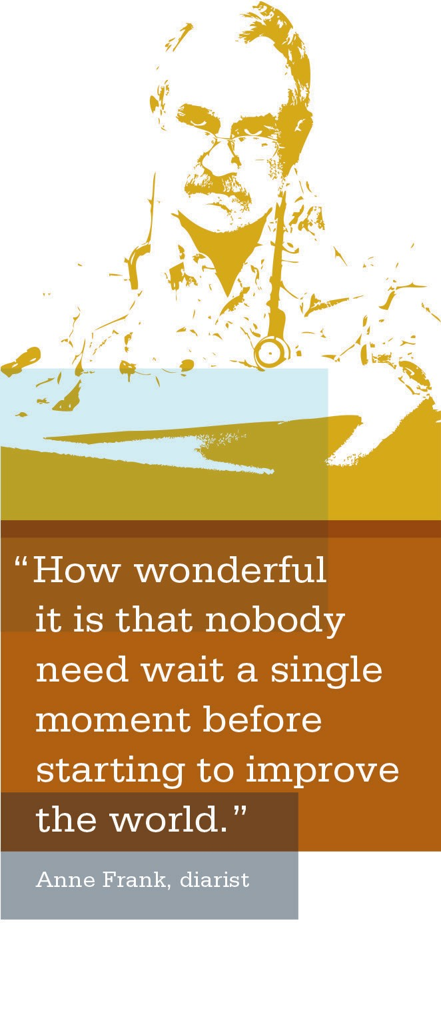
Metrics are like a dashboard in your car. They tell you how you’re currently operating in a number of areas. By tracking your metrics over time, you can determine whether the changes you are making really are an improvement, and whether the improvement is large or small.
If the metric improves, does that mean our performance is getting better?
In general, the answer is “yes,” but not always. You should be careful about paying too much attention to short-term
fluctuations in your metrics. Every metric has a certain degree of random variation built into it. In most cases, the long- term trend is a better indicator of a team’s performance.

Where to Get Performance Measurement Data
People can find data to measure performance from three general places:
  - Reports: Most common source. Created by KP regional offices and many medical centers. No additional resources are needed to generate the data, but existing data may not have exactly what you need.
  - Raw Data: Even if KP doesn’t have an existing report on the metric you need, the data may be available in a computer system and can be extracted by someone with the right pro- gramming skills. This is generally more complicated and expensive than using existing reports. The potential benefit is that you may be able to construct precisely the metric you need.
  - Self-Collected: In cases where no data currently exists in a report or database, you may want to consider collecting the data yourself. For example, KP currently does not have a computer system that records whether patient care staff are washing their hands regularly.
Before constructing your own data collection tool, check with other teams and departments doing similar work to see whether they already have created something.

Working Styles Assessment

You will be working with UBT members and UBT staff with different working styles and backgrounds. Your working style may be very different than your co-lead’s style. To work as efficiently and effectively as possible, it’s helpful to assess your working style to determine the way you prefer to work.

Knowledge of Self—Working Style Self-Assessment
Teams are made up of individuals with different work experience and backgrounds, each with his or her own partic- ular working style. There are many different working styles to think about, and every person’s individual working style plays a key role in the team’s development and success.

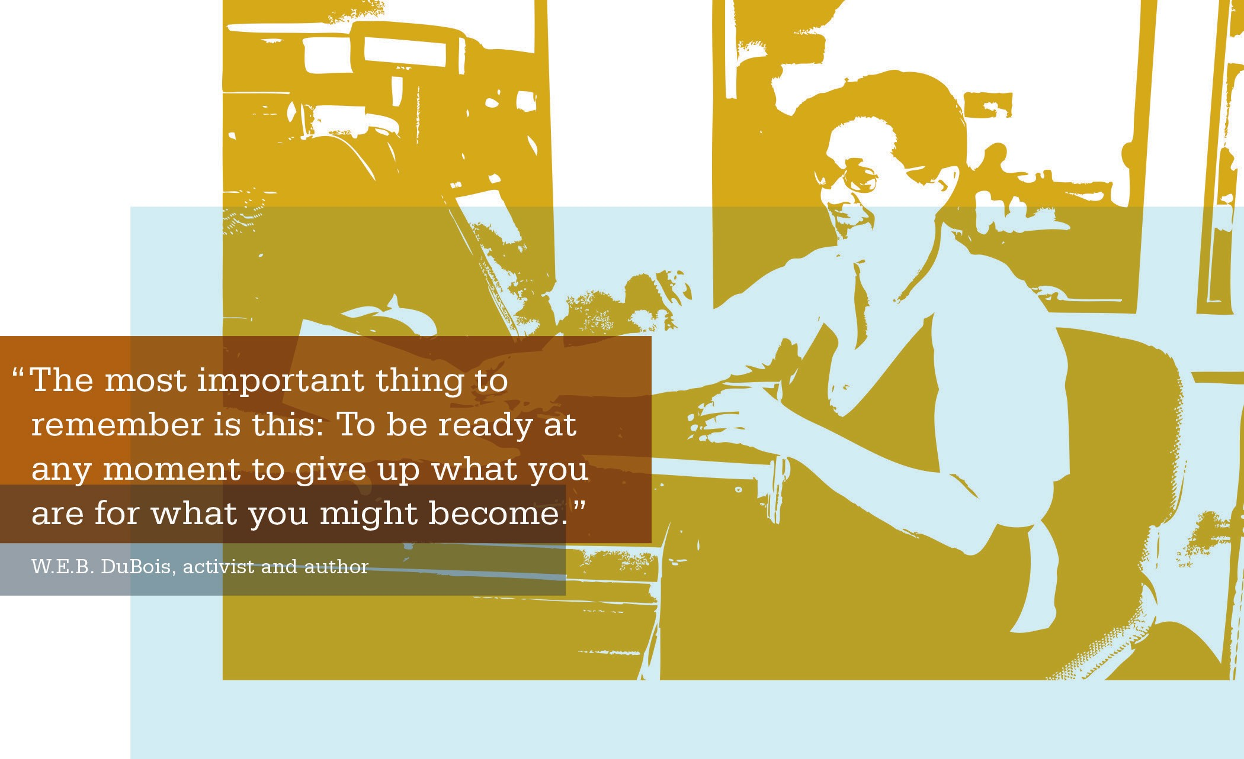

Working Styles Questionnaire
Purpose
The purpose of this brief questionnaire is to get some idea of your preferred or dominant working style.

Outcome
There are no right or wrong answers and you may find that several choices appeal to you because you prefer a combina- tion of styles.

Instructions
- Complete the questionnaire on the next page.
- Read each statement and order your responses with the numbers “1,” “2,” “3” or “4,” with “1” being the response that BEST describes you and “4” being the response
that LEAST describes you. Use whole numbers only (no fractions or decimals).
- You have approximately 15 minutes to complete the questionnaire.
- Once you have completed the questionnaire, transfer the results to the score sheet on the following page.

ACTIVITY: Working Styles Questionnaire

1. When performing a job, it is most important to me to
A [ | ] | do it correctly, regardless of the time involved.
B [ | ] | set deadlines and get it done.
C [ | ] | work as a team, cooperatively with others.
D [ | ] | demonstrate my talents and enthusiasm.

2. The most enjoyable part of working on a job is
A [ | ] | the information you need to do it.
B [ | ] | the results you achieve when it’s done.
C [ | ] | the people you meet or work with.
D [ | ] | seeing how the job contributes to progress.

3. When I have several ways to get a job done, I usually
A [ | ] | review the pros and cons of each way and choose.
B [ | ] | choose a way that I can begin to work immediately.
C [ | ] | discuss ways with others and choose the one most favored.
D [ | ] | review the ways and follow my “gut” sense about what will work the best.

4. In working on a long-term job, it is most important to me to
A [ | ] | understand and complete each step before going to the next step.
B [ | ] | seek a fast, efficient way to complete it.
C [ | ] | work on it with others in a team.
D [ | ] | keep the job stimulating and exciting.

5. I am willing to take a risky action if
A [ | ] | there are facts to support my action.
B [ | ] | it gets the job done.
C [ | ] | it will not hurt others’ feelings.
D [ | ] | it feels right for the situation.

 | A [ | ] | B [ | ] | C [ | ] | D [ | ]
 | A [ | ] | B [ | ] | C [ | ] | D [ | ]
 | A [ | ] | B [ | ] | C [ | ] | D [ | ]
 | A [ | ] | B [ | ] | C [ | ] | D [ | ]
 | A [ | ] | B [ | ] | C [ | ] | D [ | ]
TOTALS: | A [ | ] | B [ | ] | C [ | ] | D [ | ]

ACTIVITY: Your Working Style Score Sheet
Transfer the answers from the Working Styles Questionnaire onto the scoring grid below by entering the number you chose for each letter. Next, total the columns and record the answers in the space provided.

Your LOWEST score is your preferred or dominant working style. In the case of a tied score, you should pick the working style you feel is most like you.
A = Analytical B = Driver
C = Amiable
D = Expressive

My preferred working style is

TOOL: Working Style Characteristics

A–Analytical | B–Driver
- Cautious actions and decisions | - Takes action and acts decisively
- Likes organization and structure | - Likes control
- Dislikes involvement with others | - Dislikes inaction
- Asks many questions about specific details | - Prefers maximum freedom to manage self and others
- Prefers objective, task-oriented work environment | - Cool and independent, competitive with others
- Wants to be accurate and therefore relies too much on data collection | - Low tolerance for feelings, attitudes and advice of others
- Seeks security and self-actualization | - Works quickly and efficiently by themselves

C–Amiable | D–Expressive
- Slow at taking action and making decisions | - Spontaneous actions and decisions, risk taker
- Likes close, personal relationships | - Not limited by tradition
- Dislikes interpersonal conflict | - Likes involvement
- Supports and “actively” listens to others | - Generates new and innovative ideas
- Weak at goal setting and self-direction | - Tends to dream and get others caught up in the dream
- Demonstrates excellent ability to gain support from others | - Jumps from one activity to another
- Works slowly and cohesively with others | - Works quickly and excitingly with others
- Seeks security and inclusion | - Not good with follow-through

TOOL: Using Your Style with Other Styles

Your Style Other Style | Analytical | Driver | Amiable | Expressive
 | Establish priority | Take a deep | Cut short the social | Translate your
 | of tasks to be | breath, relax and | hour and get right | vision into specific
 | done. Commit to | slow down. With | down to the | tasks or goals.
 | firm time frames | analyticals, you | specifics. The more | Involve analyticals
Analytical | for your work and stick to them. | need to demon- strate you have | information you have to support | in research and developing the
 |  | considered all or | your position, | details of the plan
 |  | most options or | the better. | of action.
 |  | outcomes before
 |  | moving ahead.
 | Organize your work | Remind each other | Don’t take any- | Take time to think
 | around major | of your similarities | thing personally. | about what your
 | themes; prepare | and your need to | Getting results is | vision really is;
 | “executive | adopt qualities of | what counts with | translate it into
 | summaries” with | the other styles. | drivers; be decisive | action steps with
Driver | headings or bullets |  | and dynamic. | objectives and
 | that state the |  | Emphasize the | timelines.
 | conclusions first |  | bottom line.
 | and supporting
 | data and analysis
 | second.
 | Start off on a | Spend time up | Laugh with each | Tell them how
 | personal note, | front gaining trust | other about how | important the team
 | gravitate to project | and confidence; be | important it is | concept is to
 | specifics and | inclusive. Be sure | being relational. | making your vision
Amiable | expectations; | to be specific | Then focus on what | a reality. Give
 | emphasize the | about deadlines, | we really need to | amiables the job
 | greater good of | even when it seems | accomplish here | of team building to
 | the project. | obvious. | and do it. | make the dream
 |  |  |  | come true.
 | Jazz up your | Be patient and try | Engage the | Remind each other
 | presentation; try to | to work with a flip | expressive with | of your tendency
 | think of the BIG | chart to harness | appreciation of | to generate a lot
 | picture. Involve | creative spirits. | their vision and | of ideas without
Expressive | the expressive in developing the | Emphasize time- lines and due | creativity. Harness this energy to deal | thinking through how to implement
 | “vision” or | dates. Build in | with pesky but | them.
 | marketing of | flexibility to allow | important details
 | the plan. | the free rein of | only they can
 |  | creativity. | address.

d

ACTIVITY: Working Styles Questions
- What do others need to know about our style in order to effectively work with us?

- What are our challenges in working with each of the other working styles?

- We all have a few elements of all the styles. Do you think this is an advantage or disadvantage?

- Why is it a good thing your team has people from all these different styles?

Team Development
Stages of Unit-Based Team Development
Leaders and sponsors play an important role in the ongoing development of unit-based teams (UBTs). The more you understand about where your teams are in the developmental process, and what they need to move to the next level, the more effective you can be in supporting their forward momentum. The faster this process happens, the faster you will see results. Work with your co-sponsors to identify team status, strategize ways to help move them forward and develop a plan for long-term sustainability.
Key Tip!
Ask yourself:
Where are your teams in the developmental process?
Who is developing and who isn’t?
Why aren’t they developing? What do they need?
How can you and your
co-sponsors support their evolution to the next level?

Guidelines for Using the Following Tool
- Each month, give this tool to your teams and have them assess themselves. They must meet all the criteria in one phase before they can move to the next phase.
- As the sponsor, part of your role is to track team status monthly. The Team Assessment Tool gives you valuable information you can use to reward teams that are making progress and support those that are not moving forward at a desired rate.

Level 1 | Level 2 | Level 3 | Level 4 | Level 5
Pre-Team Climate | Foundational | Transitional | Operational | High-Performing
Unit is learning | Team is | Team is | Team has joint | Team is fully
what a unit- | establishing struc- | demonstrating | leadership, | successful and
based team is | tures and begin- | progress on en- | engagement of | collaborating to
and how UBTs | ning to function | gagement | team members | improve/sustain
work. | as a UBT. | and making | and improved | performance
 |  | improvement. | performance. | against targets.

TOOL: UBT Development and Assessment Scale

Dimension | Level 1: Pre-Team Climate | Level 2: Foundational UBT | Level 3: Transitional UBT | Level 4: Operational UBT | Level 5:  High-Performing UBT
Sponsorship | + Sponsors are identified and introduced to team. | + Sponsors trained.  + Charter completed. | + Sponsors regularly communicating with co-leads. | + Sponsors visibly support teams.  + Minimal outside support needed. | + Sponsors holding teams accountable for performance and reporting results to senior leadership.
Leadership | + Team co- leads are identified or process of identification is under way. | + Co-leads have developed a solid working relationship and are jointly planning the development of the team. | + Co-leads are seen by team members as jointly leading the team. | + Co-leads are held jointly accountable for performance by sponsors and executive leadership. | + Team beginning to operate as a “self-managed team,” with most day-to-day decisions made by team members.
Training | + Co-lead training scheduled or completed. | + Team member training  (e.g., UBT  Orientation, RIM+)  scheduled or completed. | + Advanced training (e.g., business literacy, coaching skills, metrics) scheduled  or completed. | + Advanced training (e.g., Breakthrough Conversations, Facilitative Leadership, etc.).  + Focus area-specific training (e.g., patient safety or improvement tools to address human error-related issues). | + Focus area-specific training.  + Advanced performance improvement training (e.g., deeper data analysis, control charts, improvement methods via operational manager training).
Team Process | + Traditional; not much change evident.  + Team  meetings scheduled and/or first meeting completed. | + Staff meetings operating as UBT meetings (no parallel structure).  + Co-leads jointly planning and leading meetings. | + Team meetings are outcome-based; team members are participating  actively in meetings and contributing to team progress and decision making.  + Co-leads moving from direction to facilitation. | + Co-leads jointly facilitate team meetings using outcome- focused agendas, effective meeting skills and strategies to engage all team members in discussion and decision making.  + Team makes use of daily huddles to reflect on tests and changes made.  + Team collects own data and reviews to see whether  changes are helping improve performance. | + Team beginning to move from joint- management to self-management, with most day-to-day decisions made by team members.  + Unit culture allows team to respond to changes quickly.  + Team can move from first local project to next improvement project and can apply more robust changes.  + Team measures progress using annotated run charts.
Team Member Engagement | + Minimal. | + Team  members understand partnership processes. | + Team members understand key performance metrics.  + At least half of team members can articulate what the team is improving and what their contribution is. | + Unit performance data are discussed regularly.  + Large majority of team members are able to articulate what the team is improving and their contribution. | + Team members able to connect unit performance to broader strategic goals of company.  + Full transparency of information.  + Team is working on questions of staffing, scheduling, financial improvement.
Use of Tools | + Not in use. | + Team  members receive training in RIM, etc. | + Team is able to use RIM and has completed two testing cycles. | + Team has completed three or more testing cycles, making more robust changes (e.g., workflow improvement rather than training). | + Team using advanced performance improvement training (e.g., operations manager training).  + Team can move from initial project to next improvement effort, applying deeper data and improvement methods.
Goals and Performance | + Team does not have goals yet. | + Co-leads discuss and present data and unit goals to teams. | + Team has set performance targets, and targets are aligned with unit, department and regional priorities. | + Team has achieved at least one target on a key performance metric. | + Team is achieving targets and sustaining performance on multiple measures.

The table is designed to be used by Kaiser Permanente regions as a model for developing their own unit-based team path- ways. It assesses UBTs on several dimensions of team effectiveness and is aligned with the five-point team-effectiveness rating built into UBT Tracker. Revised December 2009.

TOOL: Communicating with CARE: The Enhanced Four Habits
Goal Background
The Communicating with CARE—The Communicating with CARE is a training Enhanced Four Habits communication skills that builds on skills taught in the well known training will improve the service experience Four Habits first published in the Permanente and satisfaction scores by improving communi- Journal in 1999. CARE expands that original cation to build loyal relationships with patients, model to be relevant for non-clinical roles. members and coworkers. It will address the New industry, evidence-based practices have issue that over half of all patient/member also been incorporated into the training. complaints are related to poor service/ The method moves in a circular pattern, as communication as documented by Health each step helps to improve the effectiveness Plan and Regulatory Services. of the next and to improve handoffs to the
next interaction.
The CARE Method
The model utilizes the mnemonic CARE to help with recall of the related behaviors:

CONNECT (Invest in the Beginning)  - Choose the right attitude.  - Send the right body language signals (e.g. smile, eye contact, get to eye level, warmly touch the person).  - Warmly greet the person and anyone with them.  - Introduce yourself, role, relevant skills and background.  - Ensure your name badge is visible. | ASK (Draw Out the Other’s Perspective)  - Make a statement demonstrating familiarity with the person.  - Next, use short, open-ended questions to elicit their perspective, needs and requests.  - Speak directly to the person, even when using an interpreter.  - Listen attentively
EDUCATE (Invest in the End)  - Explain what to expect, when it will occur and how long it should take.  - Involve them in decision-making when appropriate.  - Involve them in their care by explaining what is happening.  - Check for understanding by asking and answering questions.  - Prepare the member for next steps/handoffs.  - Say “Thank you, and is there anything else I can do for you?” | RESPOND (Respond with Empathy)  - Use words and phrases that demonstrate caring and understanding  - Use body language and tone of voice that mirror your empathetic statements

For more tools and information, please visit our website at: http://kpnet.kp.org/qrrm/service2/index.html

A-HEART: Putting it all together
APOLOGIZE for  the experience  - Check your reaction  - Start with the phrase “I am sorry…”  - Apologize for the experience  - Don’t blame anyone  - Don’t start analyzing the concern or problem- solving yet | HEAR the person  - Let the person tell you what they want to say  - LISTEN for their core perceptions, concerns and feelings  - Draw out the full concern if needed  - Don’t jump to problem- solving before the person is finished | EMPATHIZE with their feelings  - Use words and phrases that demonstrate caring and understanding  - Use body language and tone of voice that mirror your empathetic statements
ASK how you can make it better  - Re-apologize for the concern  - Ask “What can I do to make this better?”  - Pause and let the person respond | RESOLVE the concern  - Use their requested solution if possible  - Provide additional options so they know all possible solutions  - If you are unable to resolve the concern to the person’s satisfaction, follow your department’s service recovery policy | THANK the person  - Start with the phase “Thank you for…”  - Appreciate the effort it took for them to express the concern  - Mention how their raising the concern allowed you to improve the care for them or for others in the future

TOOL: Service Recovery with A-HEART
Goal Background
The Service Recovery with A-HEART communi- Service Recovery with A-HEART builds on skills cation skills training will improve the service taught in the What Do You Say video training experience and satisfaction scores by improving first deployed by the National Service Quality the way disappointed customers and their department in 2008. New evidence-based concerns are addressed in order to build loyal practices have been established in the industry relationships with patients, members and since then and have now been incorporated coworkers. This is especially important since in into the method. The method introduces the healthcare more than 75% of disappointed custom- basic critical phrases, and then also introduces ers tell 9 family members and friends according the sequenced, additional elements involved in to the article Impact of Deficient Healthcare a more comprehensive interaction.
Service Quality published in TQM Magazine.
The A-HEART Method
The model utilizes the mnemonic A-HEART to help with recall of the related behaviors:

For more tools and information, please visit our website at: http://kpnet.kp.org/qrrm/service2/index.html

Notes

