Introduction

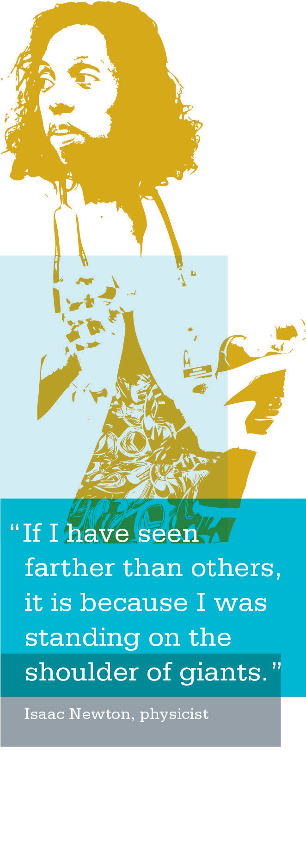
Achieving the transformation of Kaiser Permanente to a high-performing organization that puts the patient and member at the heart of everything it does requires that
unit-based team sponsors (managers, physician leaders and stewards/labor leaders) learn to mentor, coach, facilitate, advocate and reinforce the success of their teams.

Sponsors who create an environment of continuous improve- ment and actively sustain high-performing, innovative teams:
- articulate the Case for Change to help UBTs understand the issues facing Kaiser Permanente and their role in improving organizational performance;
- engage frontline employees to own the redesign of business and work processes;
- hold their own leaders and each other accountable for jointly determined performance outcomes;
- model working in partnership through open collabora- tion with their medical group, union and management partners—while each stays true to the core expectations of their role; and
- understand and promote the use of the Rapid Improvement Model (RIM) as a means to improve the performance of the entire system.

Job Aids, Tools and Templates
- When to Seek Help from Your Sponsor Tool

Seeking Help from Your Sponsor Tool
Purpose
This tool is to help the co-leads understand how a sponsor is able to support their UBT.

Outcomes
When using this tool, co-leads will have guidelines to under- stand when it is appropriate and important to seek help from their sponsors.

Instructions
Review this document and use it as a guide for seeking help and direction from your UBT sponsors.

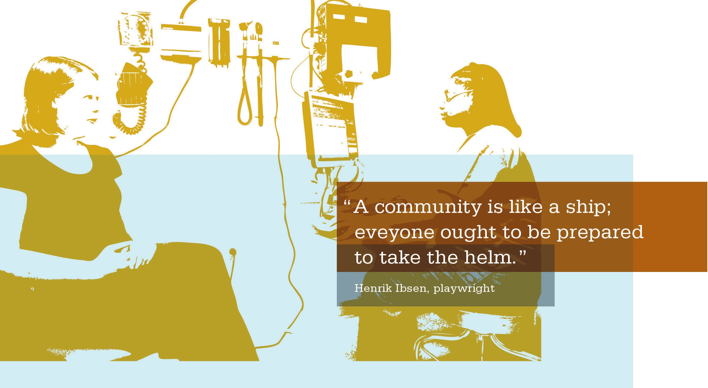

TOOL: When to Seek Help from Your Sponsor

When Seeking Clarity | - Ask your sponsor to meet with your UBT to help you communicate Kaiser Permanente/regional vision, business context and expected results.  - Ask your sponsor to help you continuously communicate the “Case for Change” message.  - Ask your sponsor to help you set key milestones and monitor progress.  - Ask your sponsor to help you identify team gaps and support personal/professional development.
When Seeking to Remove Barriers | - Identify barriers that you as co-leads are unable to remove. Seek counsel from your sponsor on how to remove barriers or ask for his/her assistance to remove the barriers.
When Seeking Additional Consultation | - When in need of additional support resources, ask your sponsor to assist in obtaining consultation and to help you make use of UBT support specialists/subject matter experts.
When Seeking Additional Resources | - If needed, ask your sponsor to allocate sufficient resources to fund your improvement work.  - Ask your sponsor to get team members performance improvement training if needed.
When Concerned about Performance Management | - Seek sponsor mentoring and advice regarding how to deal with difficult situations in team member performance or behavioral issues.
For Help with Reward and Recognition | - Seek sponsor mentoring and advice regarding questions of how to align reward and recognition systems to support the change and targeted performance improvement.

Notes

