Introduction

Once you have started your UBT and learned how to lead meetings in an organized manner, it is time to help team members work together collaboratively to meet milestones and accomplish team goals.
As your teams develop, they begin to ask, “How are we going to accomplish our work?” As team members learn to work together and participate in well-led meetings, they will have more time and energy to focus on their purpose.

Steps to Complete
When the team begins to meet and to work collaboratively, you as the co-leads will need to help the team complete the following steps to keep the progress moving forward:
- Complete the rapid improvement model (RIM) process.
- Measure and track performance.
- Use the LMP tools of interest-based problem solving (IBPS) and consensus decision making (CDM) as needed.

Complete the Rapid Improvement Model Process

The rapid improvement model is a tried-and-tested approach to achieving successful change. This model offers the following benefits:
- it is a simple approach that anyone can apply;
- it reduces risk by starting small;
- it can be used to help plan, develop and implement change; and
- it is highly effective.

LMP Process Tools
  - Interest-Based Problem Solving (IBPS)
  - Consensus Decision Making (CDM)

Measure and Track Performance

A UBT derives focus and meaning largely from the perfor- mance targets it sets for itself. When a UBT establishes a clear sense of its performance priorities and has the ability to measure and track improvement over time, team members share a common purpose. Team members then have opportunities to engage their peers in the work of taking the unit from good to great.
Early in a team’s development, UBTs identify performance indicators (with respect to the business as well as job satis- faction) that are meaningful to their unit and aligned with national, regional and local goals. Time is taken to identify these targets and agreement is reached on how best to meet them. In addition, team members learn how to obtain, read and use data to drive performance improvements in their unit.

Job Aids, Tools and Templates
The following job aids, tools and templates are included in this section of the toolkit to help you with improving performance:

Complete the Rapid Improvement Model Process
- Rapid Improvement Model Template/Understanding RIM
- Three Steps of Systems Thinking
- Testing Changes Document
- Implementing and Spreading Change Document
- PDSA Cycle Planning Sheet
- Data Collection Planning Tool
- PDSA Cycle Progress Sheet

Measure and Track Performance

- UBT Performance Tracking Tool
- Workplan
- PDSA Project Map
- Daily Huddles Worksheet

Rapid Improvement Model Template
Purpose
The UBT members may find it useful to identify what they want to achieve from their improvement work. The improvement model’s three fundamental questions for achieving improvement provide a useful framework for developing your UBT’s objectives.

Outcomes
After completion of this template, UBTs will be able to define:
- what they are trying to accomplish;
- what measures they will use to determine whether there is improvement; and
- what changes they can make to lead to an improvement.

Instructions
Provide your team with a copy of the RIM template.

Checklist for the RIM Template
[ | ] | Work with your team to answer each of the questions on the template.
[ | ] | Chart your team’s responses as you are completing the template.
[ | ] | Have a scribe take notes so you can refer to this information for future reference.

Model for Improvement  What are we trying to accomplish? | Setting Goals  Improvement requires setting goals that are time-specific, measurable and define the specific population of patients that will be affected. Goals for improvement should be aligned with department/regional goals.
How will we know that a change is an improvement?

What changes can we make that will result in improvement?

Developed by Associates in Process Improvement (API) For information, go to: www.apiweb.org/API_home_page.htm
Establishing Measures
This question focuses specifically on what your team will measure, how you will measure it and how you will know that the change is really an improvement.
Selecting Changes
All improvement requires making changes, but not all changes result in improvement. Organizations must identify changes that are most likely to result in improvement.
Testing Changes
The Plan-Do-Study-Act (PDSA) cycle is a quick way to test change in a real work setting—plan it, try it, observe the results and act on what is learned. PDSA is the scientific method for action-oriented learning.
Source: Institute for Healthcare Improvement www.ihi.org/IHI/Topics/Improvement/ImprovementMethods/HowToImprove

Understanding the
Rapid Improvement Model

The rapid improvement model has been adopted by
the LMP and the National Performance Improvement and Execution Department as an effective quality improvement methodology. RIM is a tried-and-tested approach
to achieving successful change. This model offers the following benefits:
- simple approach that anyone can apply;
- reduces risk by starting small;
- used to help plan, develop, implement and sustain change;
- achieve big gains from small, rapid tests of change;
- eliminate time wasting and dangerous work-arounds (also unwritten rules); and
- accomplish your department’s goals and improve its performance.

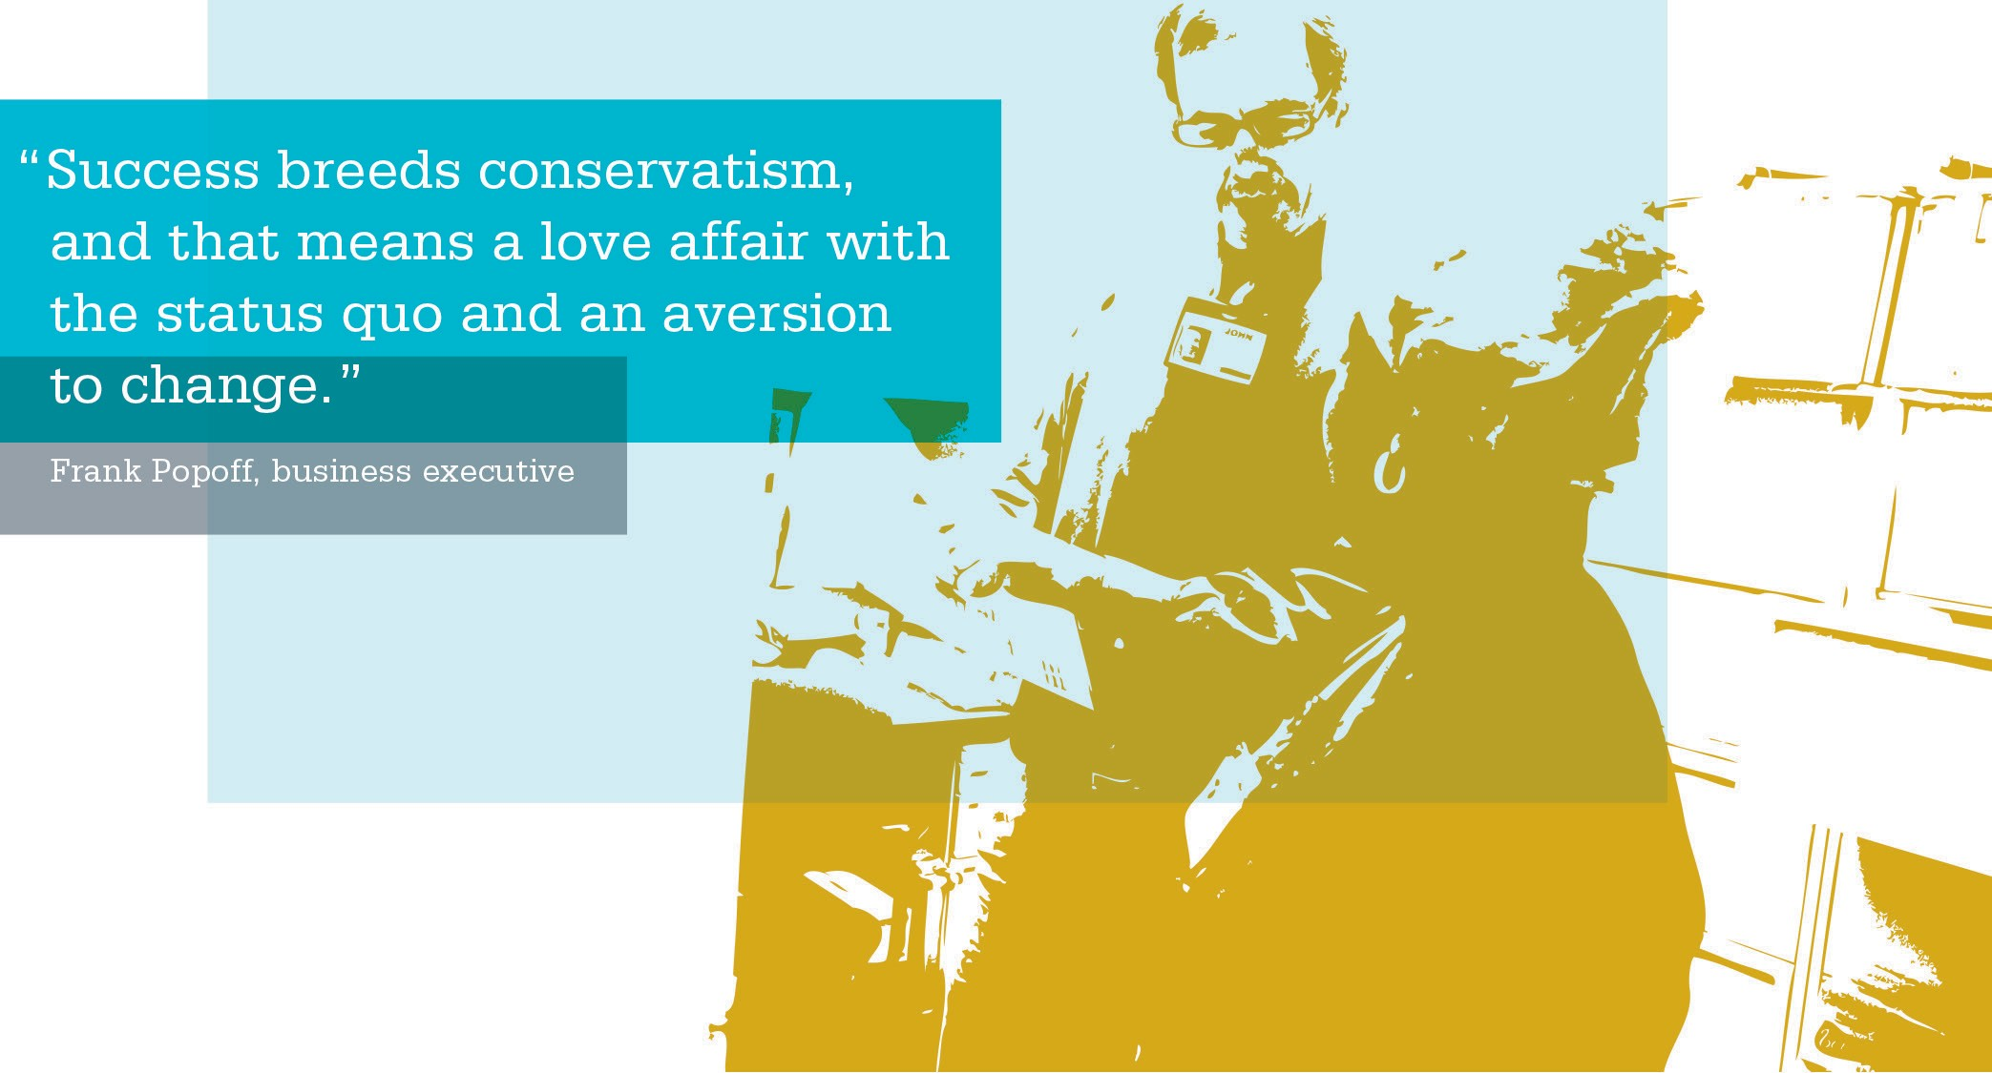

ACTIVITY: Rapid Improvement Model (RIM)

Q1. What are we trying to accomplish?
What is the overall aim of what we are doing? What are we hoping to improve?
(Increase the ability of the patient to access care? Improve how we use the skills of team members? Use our appointment capacity more efficiently?)
Q2. How will we know that a change is an improvement?
What will tell us that our changes make things better than they were before? What can we measure that will demonstrate our changes are actually an improvement? What data (opinions, observation, process data and results) will be useful?
Q3. What changes can we make that will lead to an improvement?
Include all the ways you can work toward your objective, so that you can develop plans for PDSA cycles. Think about what has worked for other people, the ideas you have yourself and innovative approaches.

Systems Thinking and Organizational Learning

As unit-based teams focus on performance improvement work, they will make changes to processes and procedures that can have a ripple effect throughout the organization. An essential part of your role as a co-lead is the ability to step back, look at the big picture and assess the impact of decisions and changes on other parts of the organization. This ability, called systems thinking, approaches problem solving by looking at the interaction of all the parts that make up the system and how improvements in one area of a system can adversely, or beneficially, affect another area. Doing so promotes organizational learning and helps break down silos.
Significant improvements can be achieved in health care when unit-based teams consider how changes affect the entire system. As a co-lead of unit-based teams, you can coach your team to incorporate systems thinking into their small tests of change, and even their day-to-day work.

Benefits of Systems Thinking:
  - Able to deal more effectively with complex problems
  - Prevent significant negative events
  - Prevent harm to patients
  - Increase staff morale
  - Get away from assignment of blame
  - Solve problems that seem unsolvable or revise ineffective solutions
  - Encourage innovation at every level

THREE STEPS OF SYSTEMS THINKING
Identify the problem | - Step back and consider the problem within the bigger system  - Focus on patterns of behavior over time, rather than a single event  - Focus on the specific system within the organization’s control that is responsible for performance issues
Brainstorm solutions | - Look for the cause of the problem or inefficient workflow  - Understand the feedback loop and ongoing process that reinforces the problem  - Take advantage of the collective brain power of the group to solve the problem  - Try to create a list of different possible solutions
Do a reality check | - Evaluate feasibility of the solutions to see if they are realistic  - Conduct small tests of change to see if an improvement can be made (RIM+)
Source: Institute for Healthcare Improvement www.ihi.org

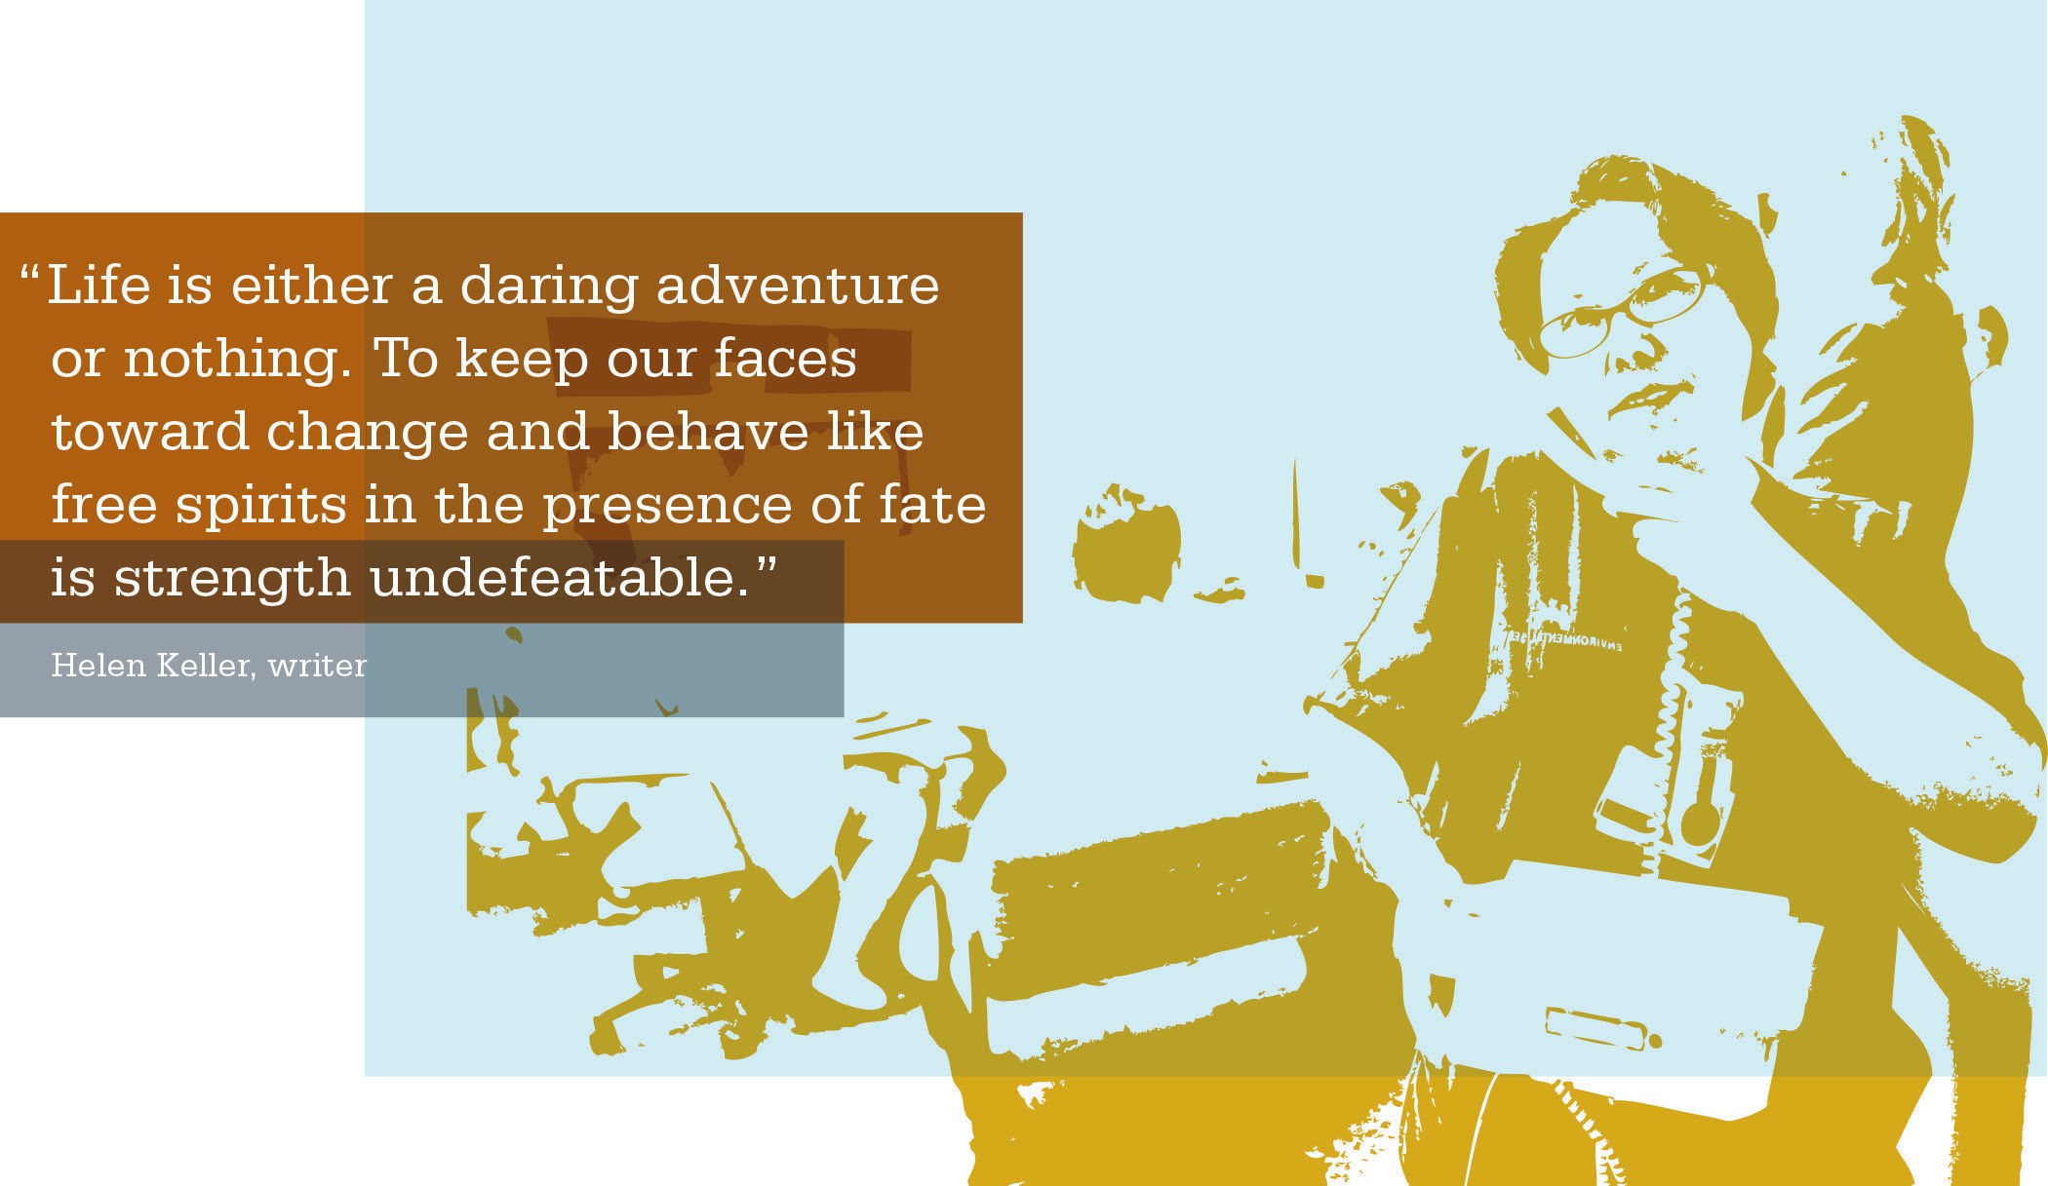

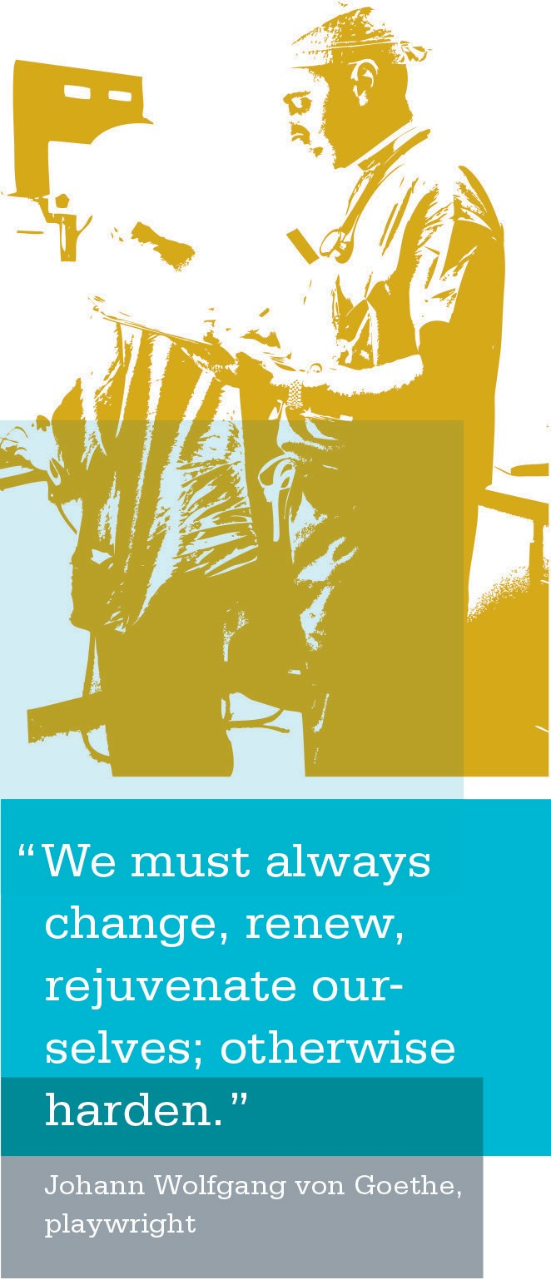
Testing Changes—Plan, Do, Study, Act (PDSA)

Once a team has mapped a process, set a goal, developed measures and a data collection plan and selected changes, the next step is to test those changes. The Plan, Do, Study, Act (PDSA) cycle is a quick way of improving work processes that allows teams to rapidly test on a small scale where a little risk taking is encouraged and failures are considered OK because we learn from them.
As a co-lead, you can coach your team to:
- Think big. Test small.
- Survey the team on how the change is working.
- Understand controlled failure is OK—it’s a chance for the team to learn.
- Debrief the failure so it is a learning experience, not a humiliation. (Ask, “What did we learn? How could we have done this differently? What will we do now?”)
- Celebrate success early and often!

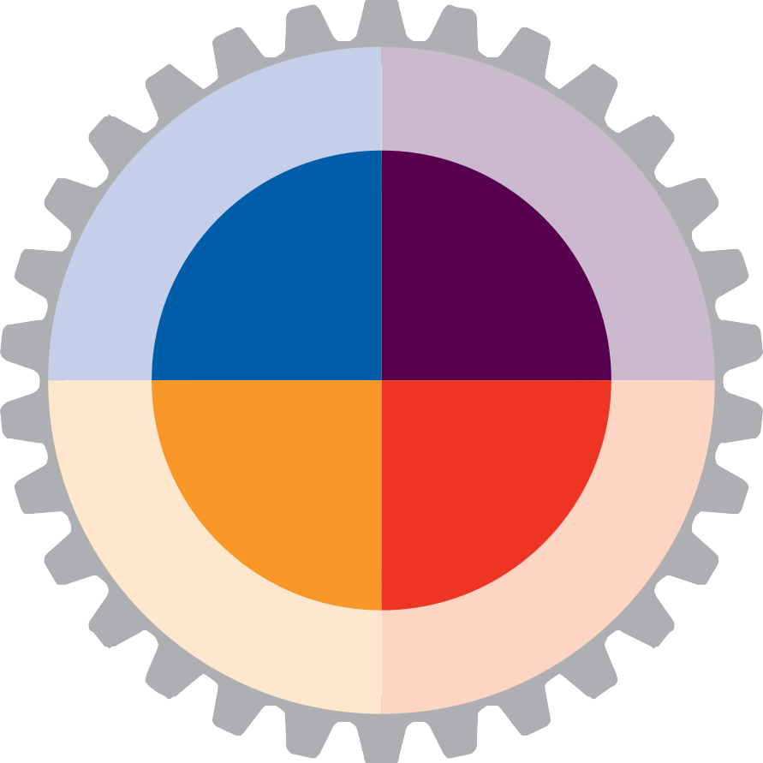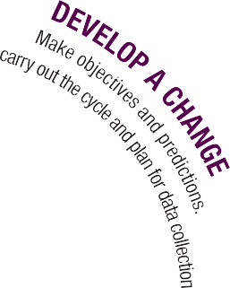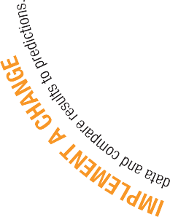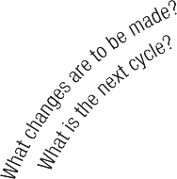

TESTING CHANGES—PLAN, DO, STUDY, ACT (PDSA)
Step 1: Plan  Plan the test or observa- tion, including a plan for collecting data. | - State the objective of the test  - Make predictions about what will happen and why  - Use a baseline—create one, if needed  - Develop a plan to test the change  (Who? What? When? Where? What data need to be collected?)
Step 2: Do  Try out the test on a small scale. | - Carry out the test  - Document problems and unexpected observations  - Begin analysis of the data
Step 3: Study  Set aside time to analyze the data and study the results. | - Complete the analysis of the data  - Compare the data to your predictions  - Summarize and reflect on what was learned
Step 4: Act  Refine the change, based on what was learned from the test. | - Determine what modifications should be made  - Prepare a plan for the next test
Source: Institute for Health Improvement www.ihi.org/IHI/Topics/Improvement/ImprovementMethods/HowToImprove

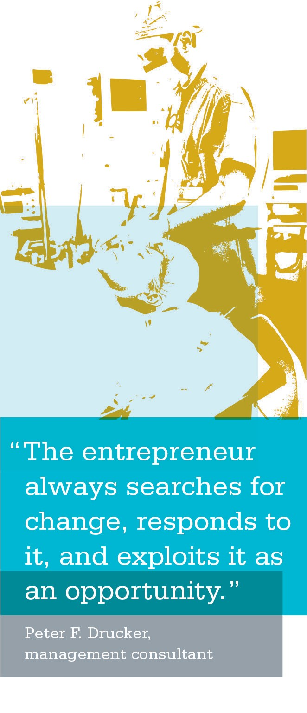
Implementing and Spreading Change

After testing change on a small scale, learning from each test and refining the change through several PDSA cycles— including testing the change under varying conditions,
on different shifts and with different staff—the change may be ready for implementation on a broader scale. Implementation is a permanent change to the way work is done and involves building change into the organization and possibly revising documents and written policies.
The following are the reasons why teams need to test before implementing change:
- increases degree of belief that change may work;
- documents expectations and learnings;
- builds a common understanding of what good looks like;
- evaluates costs and side effects of changes;
- explores theories and predictions;
- tests ideas under different conditions; and
- helps teams learn and adapt in real time.
Spread is the process of taking a successful implementation process and replicating that change or package of changes in other parts of the facility or other regions.

Leadership | Setting the agenda and assigning responsibility for spread
Set-up for Spread | Identifying the target population and the initial strategy to reach all sites in the target population with the new ideas
Better Ideas | A description of the new ideas and evidence to “make the case” to others
Communication | Methods to share awareness and technical information about the new ideas
Social System | Understanding the relationships among the people who will be adopting the new ideas
Knowledge Management | Observing and using the best methods for spread as they emerge from the practice of the organization
Measurement and Feedback | Collecting and using data about process and outcomes to better monitor and make adjustments to the spread progress
Source: Institute for Health Improvement www.ihi.org/IHI/Topics/Improvement/ImprovementMethods/HowToImprove

PDSA Cycle Planning Sheet
Purpose
PDSA stands for Plan, Do, Study, Act. Once you have decided exactly what you want to achieve, you can use PDSA cycles to test out the ideas developed from your answers to the third question (What changes can we make that can lead to an improvement?).
The key to the PDSA cycles is to try out your change on a small scale to begin with, and to rely on using many consecutive cycles to build up information to determine
the effectiveness of your change. This makes it easier to get started, gives results rapidly and reduces the risk of some- thing going wrong and having a major adverse impact.

Outcomes
After completion of this template, you will have a plan for the launch of the PDSA cycle for your team.

Instructions
Provide your team with a copy of the PDSA Cycle Planning Sheet.

Checklist for the PDSA Cycle Planning Sheet
[ | ] | Work with your team to answer each of the questions on the template.
[ | ] | Chart your team’s responses as you are completing the template.
[ | ] | Have a scribe take notes so you can refer to this information for future reference.

ACTIVITY: PDSA Cycle Planning Sheet

Name: | Date:

Overall objective that this cycle links to:
Specific objective for this cycle:
What are you going to do?
Who will be involved?
Where will it take place?
When will it take place?
What do you predict will happen?
What are you going to measure in this cycle?

Data Collection Planning Tool
Purpose
This tool helps a team determine what they will measure, how they will measure it and who will collect the data.

Outcomes
After using this tool to collect data, the UBT will be able to determine whether the change was effective and whether there were barriers that need to be removed.

Instructions
Use this tool after you have identified what actions you are going to take to test for process improvement. Make tally marks for each day to get simple data that will help you determine whether your actions are making a positive change. For more information on metrics, go to
Section 9, Appendix/Additional Resources.

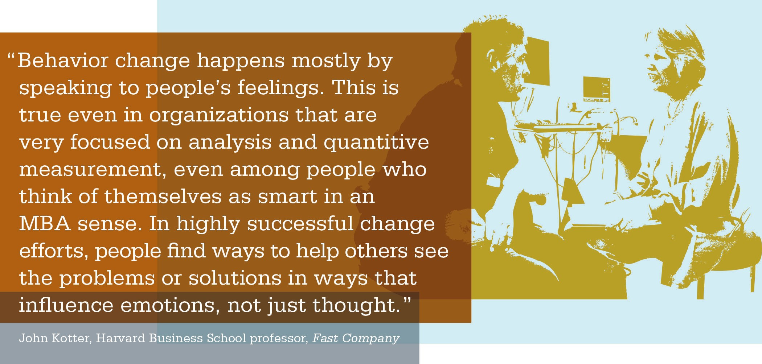

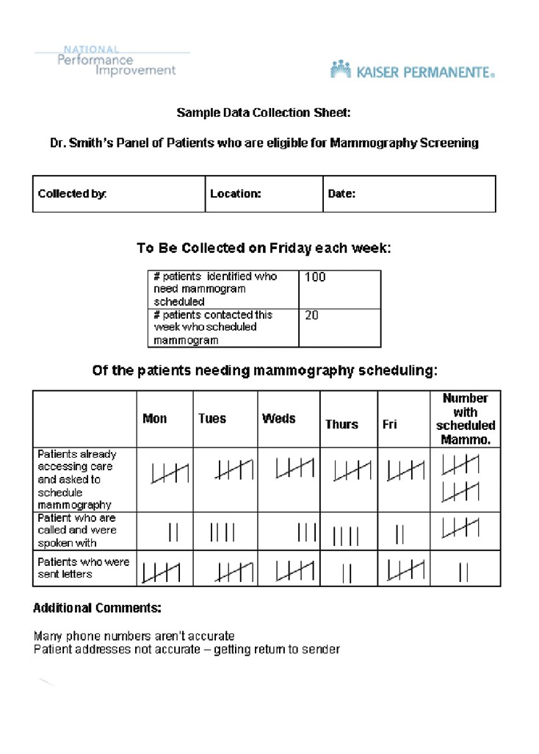

 |  | ACTIVITY: Creating a Data Collection Plan and Tool
When planning data collection, the team needs to ask itself:
[ | ] | What will we measure?
[ | ] | What are the definitions?
[ | ] | Who will collect the data?
[ | ] | How and when will the data be collected, and for how long and how often?
[ | ] | Do we have a process for collecting and entering the data?
 |  | The best people to create and test a data collection tool are frontline staff.  - Test tool ideas on paper and do so quickly before formalizing the tool.  - Collect only relevant data you can use.  - Make sure your data collection tool includes a definition of measures and information as to what is and is not included, and ensure it simplifies the information to be entered.  Example:  Identified barriers, leads to more testing ideas | Project level information (person, place, time)  Outcomes data (by week)  Process data (collected by staff during the day)

PDSA Cycle Progress Sheet
Purpose
This sheet is used to monitor progress as you carry out your PDSA cycle.

Outcomes
After completion of this progress sheet, you will have a record of what you did, the information you studied and what you will use from your PDSA cycle.

Instructions
Provide your team with a copy of the PDSA Cycle Progress Sheet. Make sure team members complete this sheet and monitor progress as they complete the PDSA cycle.

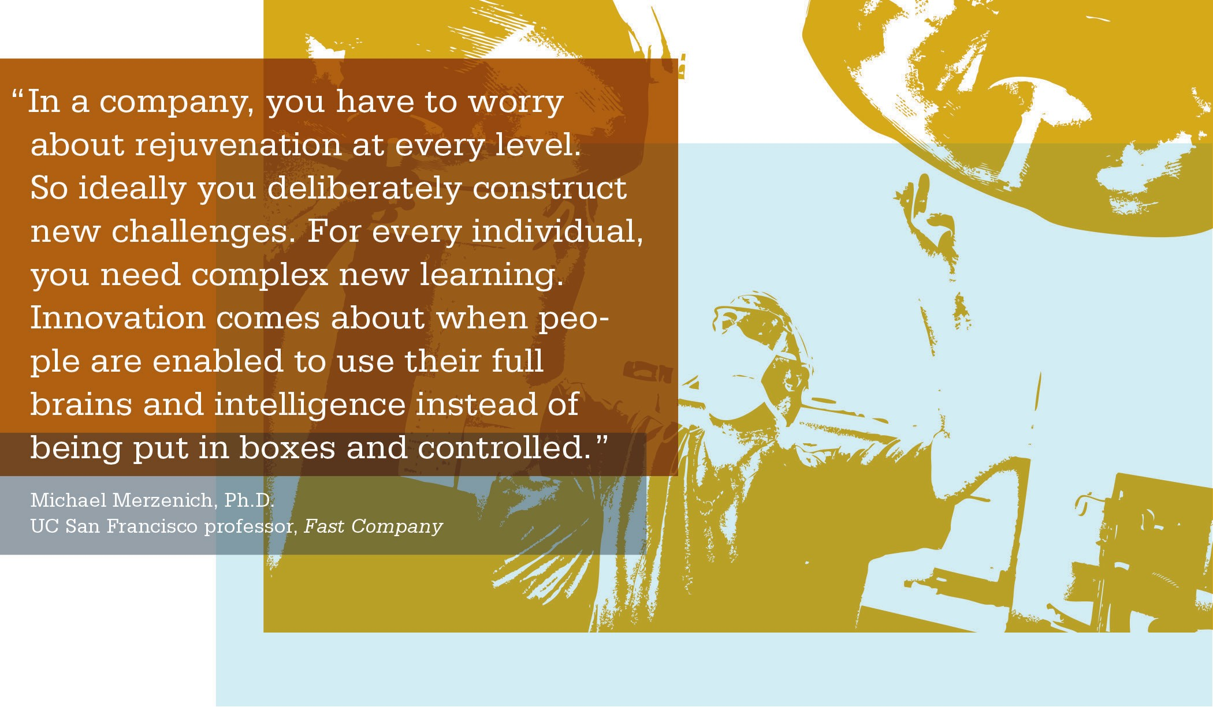

ACTIVITY: PDSA Cycle Progress Sheet
Complete this part as you carry out your cycle. Keep notes on what happens. Before completing this map, be sure you are clear on your Plan, then move to the Do, Study and Act steps.
DO
Complete this part after you have finished your cycle, having gathered your data and reflected on what happened. Include expected and unexpected results.
STUDY
Record what you will use from this cycle, or what you will do differently next time. What other tests or cycles will you do?
ACT

UBT Performance Tracking Tool
Purpose
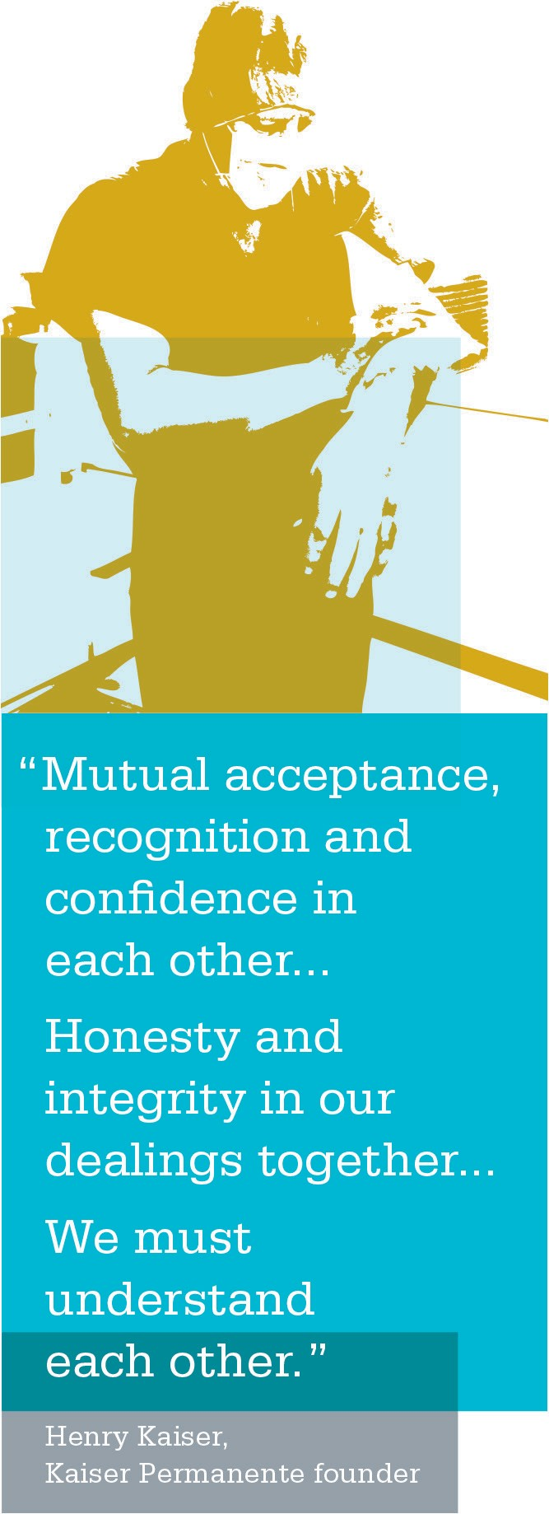
The Unit-Based Team Performance Tracking Tool provides a picture of how the UBT’s actions impact overall perfor- mance. Experience has shown that when a team focuses its attention in one area, team members see improvements in multiple areas over time. Think of dropping a pebble into
a lake and how that causes multiple ripples. For example, a team working on joint staffing improvements also may
achieve improvements in attendance, service and the budget.
The UBT Performance Tracking Tool provides metrics that many teams are using to track performance, identify and build upon baseline performance data, celebrate success over time and make improvements where necessary.
Many of the metrics that appear on the performance tracking template are measured at different intervals: Service quality results are measured quarterly, attendance rates are calculated by pay period and People Pulse results are determined annually.

Outcomes
After completion of the UBT Performance Tracking Tool, UBTs will be able to track performance and identify areas of improvement.

Instructions
Complete this worksheet with your UBT members as you begin working together. Use this as a tool to track and measure performance and celebrate results.

ACTIVITY: UBT Performance Tracking Tool

Department Information
Unit name: | Management lead name:
Union lead name: | Physician lead name:
Facility: | Location:
Phone/Tie line: | Phone/Tie line:

Metric | Baseline | Target | Jan | Feb | Mar | Apr | May | Jun

ACTIVITY: UBT Performance Tracking Tool (continued)

Metric | Baseline | Target | Jul | Aug | Sep | Oct | Nov | Dec

Instructions
  - Baseline is the year-end data for the previous year.

  - Use local targets for the current year.

ACTIVITY: UBT Performance Tracking Tool (continued)

SAMPLE NO. 1

Department Information
Unit name: | Management lead name:
Union lead name: | Physician lead name:
Facility: | Location:
Phone/Tie line: | Phone/Tie line:

Metric | Baseline | Target | Jan | Feb | Mar | Apr | May | Jun
Attendance
Sick days per FTE (annualized rate)
Overtime
% of total payroll dollars
Missed Meals/Breaks
% of total payroll dollars
POS Co-pay Collection
Workplace Safety injuries per 100 productive FTE
Service Quality
% of Member Patient Satisfaction survey/ HCAHPS, as applicable
People Pulse Opinion In my work unit, we sup- port each other to do our best work
(% agree)
People Pulse Opinion Employees in my work unit are involved in mak- ing decisions that affect our work (% agree)

ACTIVITY: UBT Performance Tracking Tool (continued)

SAMPLE NO. 1 (continued)

Metric | Baseline | Target | Jul | Aug | Sep | Oct | Nov | Dec
Attendance
Sick days per FTE (annualized rate)
Overtime
% of total payroll dollars
Missed Meals/Breaks
% of total payroll dollars
POS Co-pay Collection
Workplace Safety injuries per 100 productive FTE
Service Quality
% of Member Patient Satisfaction survey/ HCAHPS, as applicable
People Pulse Opinion In my work unit, we support each other to do our best work
(% agree)
People Pulse Opinion Employees in my work unit are involved in making decisions that affect our work
(% agree)

Completing a Workplan
Purpose
This tool may be used to help your team plan action steps toward completing a goal or initiative.

Outcomes
After completion of the UBT Performance Tracking Tool, UBTs will be able identify:
- the problem to be solved;
- a solution for the problem;
- key action steps;
- persons responsible for the action steps; and
- due dates for the action steps.

Instructions
Complete this workplan to map out how you will complete your projects. Be sure to revisit and modify as necessary.

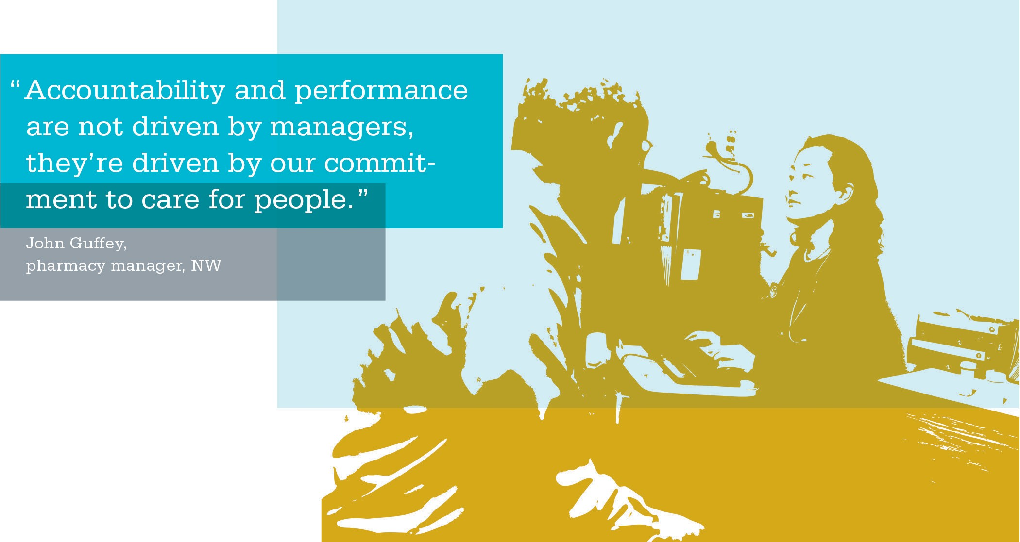

ACTIVITY: Workplan

Name of Unit: | Today’s Date:

PROBLEM TO BE SOLVED | SOLUTION  (Prioritizing by timeframe) | KEY ACTION STEPS  (List specific action steps needed to implement the solution) | PERSON RESPONSIBLE  (List specific names) | DUE BY  (List specific dates)

PDSA Project Map
Purpose
This tool is an alternate document that can be used with a UBT to document the PDSA cycle for a given performance improvement test.

Outcomes
When using this tool, a UBT is able to plot the entire PDSA cycle and plan on one document, creating an easy-to-read reference guide for all team members.

Instructions
Fill in each section as the UBT forms the PDSA cycle. Reference this document at UBT meetings and huddles. Use the bottom portion when desiring to change or create new solutions to test.

ACTIVITY: PDSA Project Map

Department/UBT Name: | Project Name:
Project Start Date: | Documentation Date:

PLAN:
What is the problem (opportunity for improvement)?
How do we know this is a problem?
Our baseline data | Comparison data |  | Regional target
How would a change affect PSP? |  | How would a change align with values?  [ ] Best Quality [ ] Most Affordable  [ ] Best Service [ ] Best Place to Work
What are the results we want (goal statement)?
What is the target measure?

DO (TEST): What possible solutions will we test?
Solution or Test 1:
Solution or Test 2:
Solution or Test 3:

ACTIVITY: PDSA Project Map (continued)

STUDY (TEST RESULTS): What happened (results with data for each solution)?
Results:
Results:
Results:

ACT:
What will we adopt? Date implemented:

What were unintended consequences? Is a new plan needed?

Daily Huddles Worksheet
Purpose
This tool is to help UBT co-leads prepare and run a daily huddle with their UBT.

Outcomes
When using this tool to prepare and guide UBT huddles, the co-leads are able to relay key information and capture key data regarding ongoing UBT performance improvement work. These daily huddles can be productively carried out in 5–10 minutes.

Instructions
Prepare for your daily huddle with your co-lead. Use this simple tool to guide your 5–10 minute conversations with your UBT.

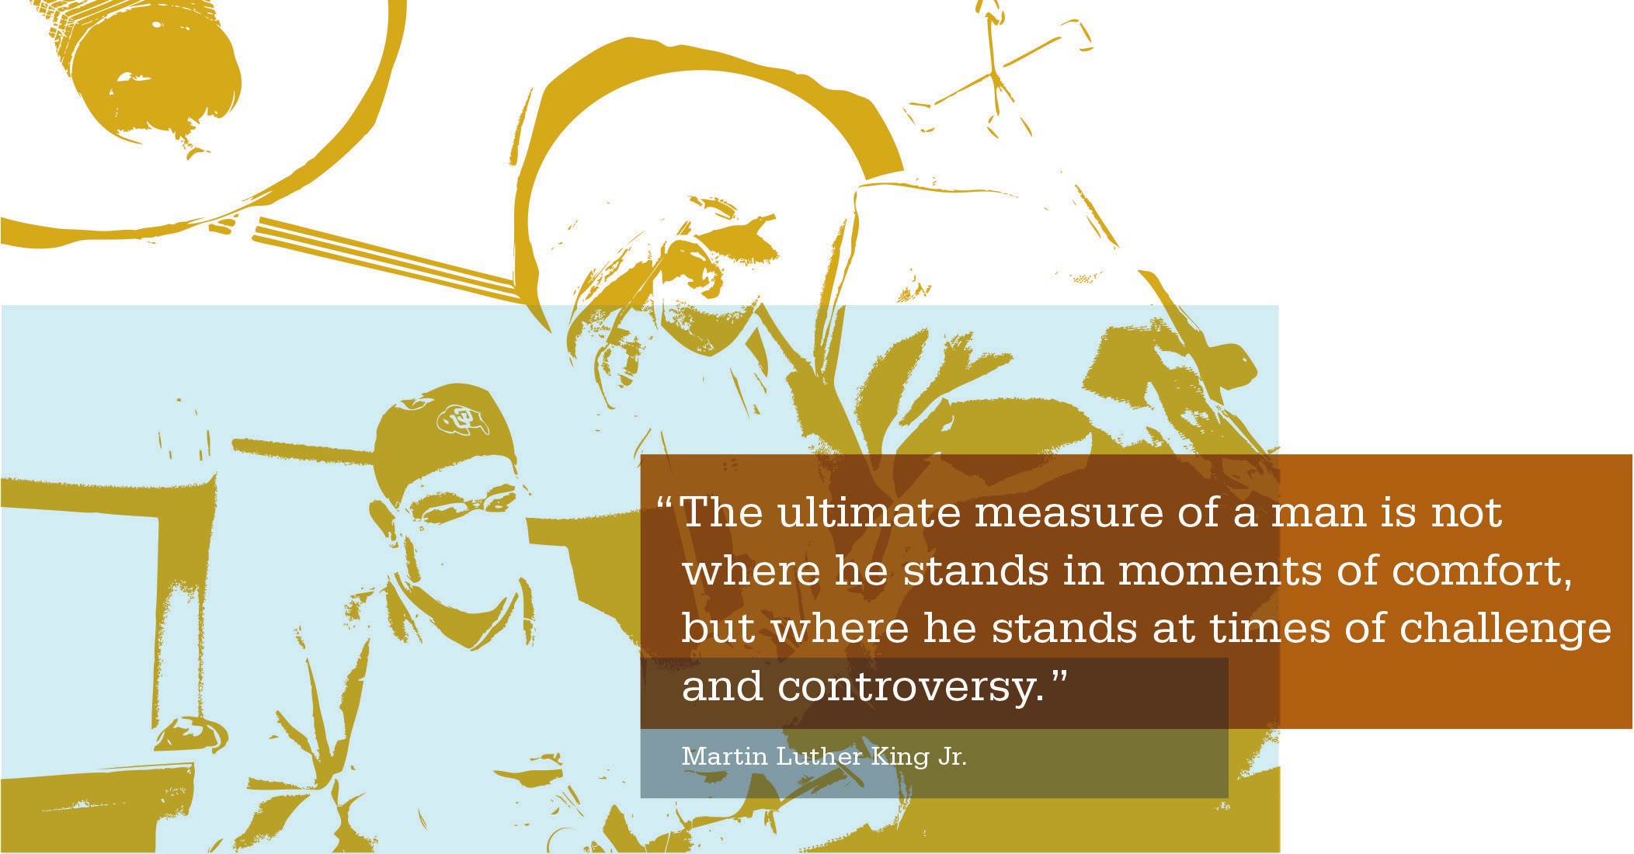

ACTIVITY: Daily Huddles Worksheet
Date:

Gather all staff for the huddle at:

Team improvement focus for the day:

Staffing:
- DOD:
• a.m. ________________________

• p.m. ________________________
• Sick calls: ________________________________________________________
- Clinician coverage/special
concerns: ____________________________________________________ Alternate work focus for the day:

Meetings/in-services today:

News, issues, urgent updates:

Staff celebrations:

Other:

Source: KPNW UBT Implementation Team

LMP Process Tools: Interest-Based Problem Solving and Consensus Decision Making
Purpose
Interest-based problem solving (IBPS) is an issue-resolution process that addresses individual and group differences.
Consensus is a form of group decision making. Both of these process tools are used routinely in the Labor Management Partnership.

Outcomes
IBPS may be used with your UBT if there is a situation that occurs that requires an issue resolution. The IBPS process can help a UBT focus on key interests group members share and come to an agreement through consensus that meets mutual interests and solves the issue at hand. IBPS is not a tool for process improvement, but rather a tool to resolve issues within a team.

Instructions
Your team may benefit from having a neutral facilitator taking them through the process of IBPS and arriving at a solution by consensus. Use the following job aids to assist you in explaining and carrying out the process if a facilitator is not available.

Interest-Based Problem Solving (IBPS)
Interest-based problem solving (IBPS) is an issue-resolution process that addresses individual and group differences.
Participants work together to reach agreement by sharing information and remaining creative and flexible, rather than by taking adversarial positions.

IBPS can be hampered by lack of trust, support, information or training. Once you eliminate these barriers, IBPS resolves issues quickly, enhances relationships and builds trust. It helps create a more constructive work environment and can improve services and health care affordability.
If you discover your team is unable to move forward because of relationship issues or lack of trust, one option is to recommend your team engage in IBPS. This process is best led by a neutral facilitator. You can help the team get this resource, if needed.

INTEREST-BASED PROBLEM SOLVING
Step 1: Define the Problem
Step 2: Determine Interests
- Develop Question
  - Contains issues
  - Begins “How might we?”
- No “Yes/No” Answers
- No Solutions
- No Accusations
- Separate Interests
  - Needs
  - Concerns
- Identify Common Interests
Step 3: Develop Options
Step 4: Select a Solution
- Brainstorming
- Best Practice
- Expert Panel
- Straw Design
- Screen Options
- Shorten List
- Develop Standards
- Test Options to Standards
- Decide on Solutions
Source: Northern California UBT Handbook http://kpnet.kp.org/ncal/lmp/

SECTION 4 | COMPETENCY: IMPROVING PERFORMANCE | LMP PROCESS TOOLS

Consensus Decision Making Purpose
Consensus is a form of group decision making. Everyone discusses the issues to be decided so that the group benefits from the knowledge and experience of all members. In order for consensus to occur, every member of the group must be able to support the decision.
Outcomes
When UBTs are deciding on what small test of change to conduct with RIM, they should use CDM to make that deci- sion. As a sponsor, you can help your co-leads know what decision-making methodology to use at different times.
Instructions to Test for Consensus
  - Has everyone been heard?
  - Can everyone live with the decision, even though it may not be your first choice?
  - Will everyone actively support the decision?

Other Important Points to Remember
  - Respect the different perspectives of others in order to understand the issue fully.
  - Listen with at least as much dedication and commitment as you speak.
  - If the group is “stuck,” get some advice about ways to move beyond it. Before you begin addressing an issue, it may be best to determine a fallback plan; that is, how the decision will be made if the group truly cannot move forward (for example, refer to sponsors, charter a subgroup, etc.).
CONSENSUS DECISION MAKING
DO: DON’T:
- Share information ■  Agree too quickly
- Listen ■  Trade or bargain
- Be open to new roles ■  Vote
- Offer alternatives ■  Penalize standouts
TESTING FOR CONSENSUS
- Has everyone been heard?
- Can everyone live with the decision?
- Will everyone actively support the decision? (Can you identify behaviors that support the decision?)

