Introduction

As a co-lead, you’ve been given the role of leading the unit- based team to achieve results. An essential competency to leading a team is to effectively run team meetings. Teams thrive under conditions where the agendas are well planned, meetings are facilitated to best use the allotted time, notes are kept accurately and agreements with action items are spelled out clearly.

Job Aids, Tools and Templates
- Planning a Meeting Template
- Agenda Planning Worksheet
- Opening, Running and Closing a Meeting Checklists
- Charting Tools
- Time Guidelines for Meetings Template
- Meeting Notes Template
- Checklist for a Sample Meeting Evaluation
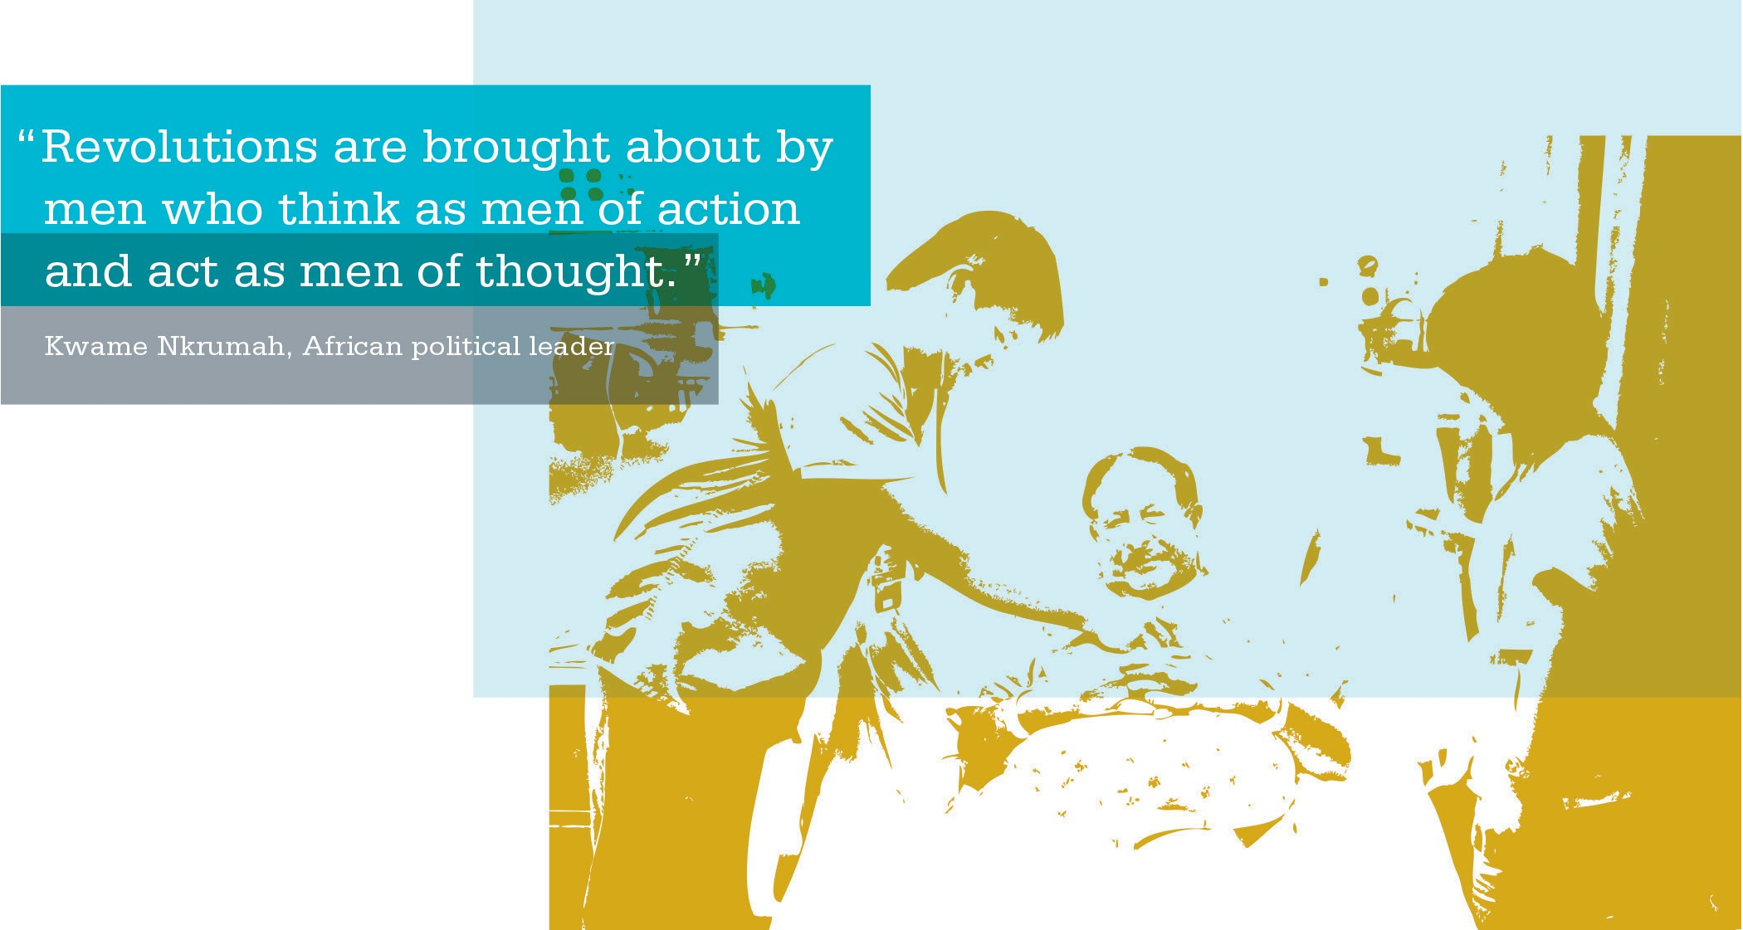

SECTION 3 | COMPETENCY: LEADING MEETINGS

Planning a Meeting Tool
Purpose
This tool identifies the key steps you should complete to plan an efficient meeting.

Outcomes
After reviewing and following the instructions and information on this list, you will be able to set up, conduct and follow up efficiently on a meeting.

Instructions
Review this list before your next meeting and take time to answer the questions on the list. Make sure you have carefully planned and prepared for all items on the list.

PLANNING A MEETING TEMPLATE
Purpose | Is the purpose for sharing information, solving problems or resolving issues?
Stakeholders | Who is affected by the potential outcome of this meeting? Is there a win-win situation?
Desired Outcomes | What are the concrete and realistic meeting outcomes?
Agenda Topics | Does the agenda accomplish the desired outcomes and encourage commitment and involvement? (See Agenda Planning Worksheet.)
Attendees and Roles | Who will attend the meeting and who will perform the key roles of the meeting (such as facilitator or scribe)?  Facilitator: Provides neutral facilitation of partnership processes, as needed. Helps team become self sufficient in applying partnership tools and processes.  Scribe: Creates a visible record of the meeting. Writes down team members’ ideas using their words. Remains neutral and does not participate in content. Not a decision maker.
Room Arrangements | How can you best set up the meeting space for maximum participation and attention?
Decision-Making Method | How much involvement will there be in making decisions, and are participants trained in the process to be used?

ACTIVITY: Agenda Planning Worksheet
Purpose
These worksheets are tools to help plan your meetings.
Outcomes
Complete a worksheet to plan the purpose, desired outcomes and process of your meeting.
Instructions
Fill in the blanks on one of the worksheets to plan your next meeting. Use the table at the bottom of the worksheet to think about and plan the process steps for your meeting.
Use this form to plan the agenda for your next meeting.
SAMPLE NO. 1
Group/Meeting Name:

Date: Time: from: to:

Location:

Meeting Leader:

Purpose:

Desired Outcome: By the end of the meeting, we will have:

ACTIVITY: Agenda Planning Worksheet (continued)

SAMPLE NO. 1 (continued)

What (Content) | How (Process) | Who | Time
Opening:  - Context  - Desired Outcome  - Agenda  - Roles | - Present  - Check for Understanding  - Check for Agreement
During:
Closing:  - Next Steps | - Agree on Action Plan
Follow-up:  - Meeting Evaluation | • +/∆ |  | 5 minutes
Copyright, Interaction Associates Inc., 2007. Used with permission.

Agenda | Outcome | Process | Time
What topics will we cover? | By the end of the meeting what will we have accomplished? | What steps will we take on the way to the outcome? | How much time will it take?
Agenda Review | - Identify other areas of interest  - Confirmed agenda for meeting | - Review the agenda  - Ask for other items to be added to the agenda  - Prioritize items considering importance, urgency and time available  - Identify an action items recorder and a MAP scribe | 5 minutes
Information Updates | - Provide critical information that could not be more effectively transmitted in any other format | - Brief presentation of information by manager and/or other UBT co-lead, UBT representative team member, charge nurse, project leads or others  - Summarize how information should be used by staff after the meeting | 10 minutes
Update Current Projects | - Completion of or progress on projects started earlier | - Identify current status  - Report on action items  - Identify next steps (if project is slowed, identify and clear barriers) | 15 minutes

ACTIVITY: Agenda Planning Worksheet (continued)
SAMPLE NO. 2
Meeting Date (and time if needed):

Participants (write names here or use participant sign-in sheet; plan how information will get to those not present):

Source: Roxanne WhiteLight, Consultant, KPNW

ACTIVITY: Agenda Planning Worksheet (continued)

SAMPLE NO. 2 (continued)

Agenda | Outcome | Process | Time
What topics will we cover? | By the end of the meeting what will we have accomplished? | What steps will we take on the way to the outcome? | How much time will it take?
Performance Review | - Identified opportunities to improve unit performance or engagement | - Alternate months: Review performance data one month and engagement needs the next month to prioritize next projects  - Improvement data: Identify status of unit on regional goals  - Engagement indicators: Review our effectiveness in team meetings and our ability to cope with changes (our own projects and other sources)  - Identify success and celebration plans  - Identify areas of needed improvement  - Discuss how to address needed improvements (new RIM, other engagement strategy, etc.) | 10 minutes
Action Items | - Confirmed action items with names and due dates | - Review assignments made and set due dates for completing them  - If team members are absent, confirm who/ how they will be updated after the meeting | 5 minutes
Plan for Continued Engagement | - Completed communication map | - Identify who is missing from the meeting  - Select staff to communicate with them  - Identify key information and key questions | 10 minutes
Summary and Feedback | - Identify what worked and what didn’t | - Summarize the actions and findings for the meeting  - Identify deltas and pluses  - Ask and plan “How can we improve our UBT meeting next month?” | 5 minutes
Source: Roxanne WhiteLight, Consultant, KPNW

SECTION 3 | COMPETENCY: LEADING MEETINGS

Opening, Running and Closing a Meeting Checklists
Purpose
These checklists provide key action items to complete when opening, running and closing a meeting.

Outcomes
Following the action items on the checklists will ensure you are running an effective meeting.

Instructions
Review the checklists before, during and after your meeting to ensure you have completed the action items necessary to run an effective meeting. For any action items you may have missed, plan on how you will better address them for your next meeting.

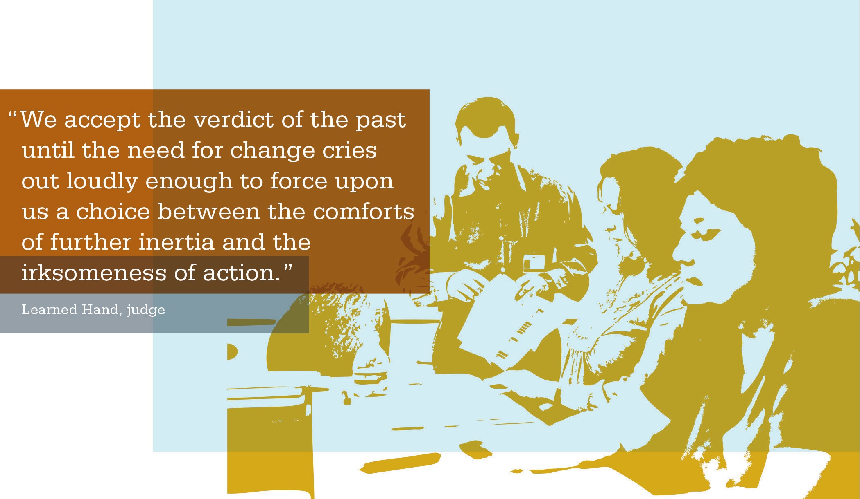

ACTIVITY: Meeting Checklist

OPENING A MEETING

Action Items
[ | ] | Ask participants to introduce themselves (if necessary)
[ | ] | Clarify your role as a co-lead
[ | ] | Clarify the roles of other members (facilitator, stakeholders and guests)
[ | ] | Conduct warm-up activity (when appropriate)
[ | ] | Clarify meeting purpose or objectives
[ | ] | Review agenda and ask the group if there are any additions, deletions or changes
[ | ] | Ensure there is an agreement on the agenda before moving forward
[ | ] | Specify time frames and appoint a timekeeper (when needed)
[ | ] | Take care of housekeeping items (e.g., location of restrooms, parking validation, etc.)
[ | ] | If the team has no ground rules, have the group set up ground rules for the session (if the team already has created ground rules, post them where they are visible and quickly review them)
[ | ] | Set up a Parking Lot sheet to keep track of pending or unresolved issues for later review
[ | ] | Proceed with the agenda

SECTION 3 | COMPETENCY: LEADING MEETINGS | OPENING, RUNNING AND CLOSING A MEETING CHECKLISTS

ACTIVITY: Meeting Checklist (continued)

RUNNING A MEETING

Action Items
[ | ] | Manage the Discussion  - Ask clarifying questions  - Tolerate silence  - Mobilize team knowledge—ask key questions to key members  - Encourage sharing of diverse thoughts and ideas  - Build team memory—use flip charts to capture ideas, action items and decisions made  - Use their words  - Use Parking Lot to stay focused
[ | ] | Balance Participation  - Balance co-lead roles and responsibilities  - Include everyone  - Make eye contact  - Use round-robin technique—seek input by engaging each person around the table  - Check in with less outspoken members  - Appreciate all team members’ input
[ | ] | Guide LMP Processes  - Clarify and require consensus agreements  - Introduce interest-based problem solving (IBPS) when appropriate  - Clarify and lead brainstorming when appropriate  - Clarify and lead sticker ranking when appropriate  - Clarify and lead straw design when appropriate  - Confirm consensus visually before moving on—everyone does “thumbs up”

Action Items
[ ] | Manage Transitions  - Summarize the topic and set the context for each discussion  - Use clear transitions  - Use agenda as a road map
[ ] | Identify Strategic Moments  - Note moments of team agreement  - Recognize progress and accomplishments as they occur  - When the team is stuck, note the cause and determine how to proceed  - Summarize key points

Action Items
[ ] | Confirm written agreements with the team
[ ] | Ensure the team has detailed action plans with names, accountabilities and dates
[ ] | Review items listed in the Parking Lot with the group and create plans for addressing them
[ ] | Create a draft agenda for the next meeting
[ ] | Create a consensus agreement on the communication plan, capturing the what, how, who and when
[ ] | Use the Checklist for a Sample Meeting Evaluation tool to prepare a written evaluation of the meeting ( + / ∆ )
[ ] | Allow members to express how they feel about their work

ACTIVITY: Meeting Checklist (continued)
RUNNING A MEETING (continued)

CLOSING A MEETING
As a co-lead, one of your key contributions is to ensure decisions are arrived at
and detailed action steps are in place before the team adjourns. To ensure successful outcomes, you must allow enough time to accomplish the following:

Charting During a Meeting
Purpose
Capturing the team’s work on chart pads and posting
pages on the wall creates visual focus for team members and allows for group agreement on details prior to closing
the meeting.

Outcomes
Visual capture of all agreements, action items, future agenda items, communication planning and Parking Lot ideas for later meetings.

Instructions
Before each meeting begins, post five pieces of chart paper on the wall with the following headings:
- Agreements
- Action Items
- Future Agenda Items
- Communications Needed
- Parking Lot
Capture ideas/decisions throughout the meeting on the appropriate chart papers and use for meeting notes and bring back to future meetings as a reference.

ACTIVITY: Charting

Here’s a look at what you can accomplish through the use of charts:

CHARTING HEADLINES
Agreements | To capture consensus decisions accurately.
Action Items | To record anything that needs to be done between meetings (completed with the name of the people responsible and the deadline dates). You can post a page with these column headings: What, Who and By When
Future Agenda Items | To capture anything missed and/or important that should be revisited in a future meeting, and also anything additional that the group would like to discuss. Creating a draft of the next meeting agenda saves time while planning between meetings.
Communications Needed | To list agreed-upon talking points that each person on the team should discuss with constituents after the meeting, to be sure that everyone is kept informed in a consistent and thorough manner.
Parking Lot | To record items that will not be addressed in the meeting or may be out of a team’s scope, but will require follow-up or additional information.

Time Guidelines for Meetings
Purpose
This worksheet provides guidelines on the timing of meetings based on the desired outcomes.

Outcomes
After reviewing this worksheet, you will be able to determine how lengthy your meeting should be based on the outcomes you wish to achieve.

Instructions
After you have planned the topics of your agenda for a meeting, review the chart to determine the estimated time frame for the meeting.

ACTIVITY: Time Guidelines for Meetings

Typical meeting outcomes:
  - Share information
  - Make decisions or obtain agreement
  - Create documents (such as charter, work and plans)
  - Solve problems

MEETING LENGTH | TYPICAL MEETING OUTCOMES
1 hour or less | - Share information  - Follow up from last meeting  - Feedback
1-2 hours | - Review data  - Make simple decisions  - Solve simple problems  - Determine next steps  - Delegate tasks (that is, assign subcommittees)
3-4 hours | - Conduct an issue resolution  - Outline a work plan  - Start the process of tackling a complex problem  Including some or all of the following:  - Share information or feedback  - Follow up from last meeting  - Review data  - Make or finalize decisions  - Solve simple problems  - Determine next steps  - Delegate tasks (that is, assign subcommittees)
4-8 hours | - Problem solve  - Develop an action plan  - Create documents  Including some or all of the following:  - Conduct an issue resolution  - Outline a work plan  - Start the process of tackling a complex problem  - Share information or feedback  - Follow up from last meeting  - Review data  - Make or finalize decisions  - Solve simple problems  - Determine next steps  - Delegate tasks (that is, assign subcommittees)

Meeting Notes Template
Purpose
This template may be used to take meeting minutes and capture action items that are to be completed from your meetings.

Outcomes
Complete this worksheet at meetings to:
- document discussions and agreements;
- write down action items;
- identify who is responsible for completing action items; and
- record the due date of action items.

Instructions
Use this template during your meetings to record meeting information. Be sure to include the date and subject in your meeting in the file name for future reference.

ACTIVITY: Meeting Notes

Timekeeper: | Insert your team name here:
Recorder:
Facilitators: | Insert date of meeting here:

MEETING NOTES
Topic | Discussion and Agreements | Action Item | Responsible Person and Deadline

Sample Meeting Evaluation—Plus/Delta
Purpose
At the end of a meeting, an evaluation should be completed to identify what processes worked during the meeting and what processes need improvement.

Outcomes
By completing an evaluation, you will be able to make changes to make sure future meetings run more efficiently.

Instructions
At the end of your next meeting, complete an evaluation using the plus/delta method.

Checklist for a Sample Meeting Evaluation
[ | ] | On a blank flip chart or whiteboard, draw a line down the middle to create two columns. Label one with a + and the other with the ∆ (delta symbol). You also can write the titles, “What Worked?” and “What Could Be Improved?”
[ | ] | Ask for team members to share their feedback.
[ | ] | Use this information for future reference. For any areas that need improvement, make sure you find a way to improve these areas before your next meeting.

+  WHAT WORKED | ∆  WHAT COULD BE IMPROVED
- Great ideas  - New sense of possibility and direction  - New ways of looking at issues  - Using a facilitator  - Pairing off to brainstorm ideas  - Confirming agreements at end of meeting  - High confidence that we will succeed | - Defensiveness at the beginning  - Need to have store managers attend next meeting—get their ideas  - We didn’t all return promptly from break  - We should share responsibility for recording

SECTION 3 | COMPETENCY: LEADING MEETINGS

Notes

