SECTION 1 | INTRODUCTION AND CONTEXT SETTING

Introduction of Unit-Based Teams and Setting Context

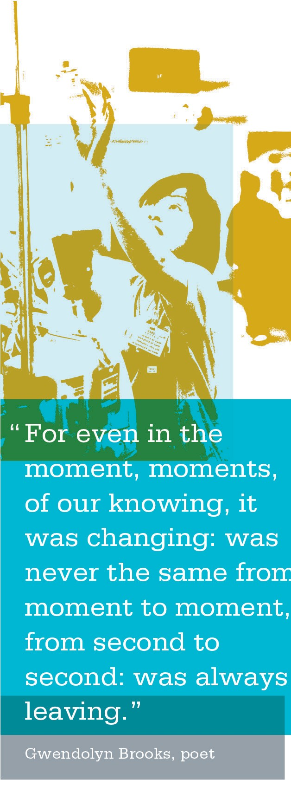
As a co-lead, you will need to set the context for why there is a need for unit-based teams. This means communicating clearly that performance improvement through employees working in unit-based teams is critical to the success of Kaiser Permanente.
To ease their minds and set a strong foundation for
unit-based team members to begin working together, it’s important to begin with an organized approach, clearly setting the context of why the work of unit-based teams is so important. A key tool to help you set the context is the Case for Change video.
Early in the formation of a UBT, the sponsors and/or
co-leads will introduce the concept of the Case for Change as a national message around the need to focus on performance improvement.
The following job aids, tools and templates are included in this section of the toolkit to help you:
- Case for Change video
- Case for Change activity

SECTION 1 | INTRODUCTION AND CONTEXT SETTING | INTRODUCTION OF UNIT-BASED TEAMS AND SETTING CONTEXT
Instructions: Have a discussion regarding Kaiser Permanente’s Case for Change.
[ | ] | Play the Case for Change video for your team.
[ | ] | After the video, debrief by asking and discussing the following questions:  - What stood out for you in this video?  - What is different about this message that you think is important to share with your team?
[ | ] | Distribute a copy of the message mapping tool to the team.
[ | ] | Read through the key message in the first column of the tool.
[ | ] | Ask team members to fill in the three columns on the tool. In the first blank column, they are to write in their own words what the message means to them. In the second blank column, they should describe some examples of what the message might look like in their workplace. In the third blank column, they are to write suggestions for how they might improve in these areas.
[ | ] | Allow team members 15 minutes to complete the message mapping tool.
[ | ] | After the team members complete the tool, review their answers with the entire group.

ACTIVITY: Case For Change—Elevator Speech
Purpose
UBTs are key to transforming Kaiser Permanente to be the future of health care. The Case for Change activity provides team members with an opportunity to identify why this transformation is important and helps them make meaning out of Kaiser Permanente’s key message regarding the Case for Change.

Outcomes
After watching the video and completing the message mapping tool, UBT members will be able to state in their own words what Kaiser Permanente’s key message on the
Case for Change means to them in their workplace and identify how they might improve in these areas.

SECTION 1 | INTRODUCTION AND CONTEXT SETTING | INTRODUCTION OF UNIT-BASED TEAMS AND SETTING CONTEXT

ACTIVITY: Message Map—Elevator Speech

This guide will help you use everyday workplace opportunities to communicate about transformation.

Key Message | Supporting Messages | In My Own Words | What’s an example of this in my workplace? | How might we improve in this area?
Our historic mission is | KP is unique in this country—
to provide accessible, | a nonprofit with a strong social
high-quality health care | mission and a commitment to total
to working families. | health, providing care under
 | one roof.
But our mission and | A few giant insurance companies with
model of care are | deep pockets are competing fiercely
threatened by the | for our members.
changing health care market and new political and economic forces. | The cost of health care in the United States is rising much faster than family incomes and people just can’t afford it anymore.
The best way to | One way we are doing that is through
strengthen KP and | our LMP, which offers us a model
ensure its growth is to | for patient-centered care through
put our members and | unit-based teams. UBTs support
patients at the center | performance and innovation.
of our work, and offer them the best service and quality and  the most affordable health care. | All of us, regardless of our role in the organization, are looking at how we need to work differently to provide the best quality, the best service and the most affordable care in the best
 | place to work.
This means we have | For example, UBTs are using
two jobs: doing our | PDSA rapid improvement tools to
work well, and figuring | make improvements in service,
out how to do it better. | quality and cost.
And this is something
we take seriously and
are acting on.
We’re changing to | Forty-seven million people are
meet our challenges, | uninsured, and millions more are
and if we can get it | underinsured—creating unnecessary
right, we’ll be a model | suffering and premature illness
for others and can | and death.
transform health care in the United States. | If we fail, the best hope for American health care will be extinguished
 | and we will face a long decline in
 | our living standards.
 | If we succeed, our outcomes will
 | establish us as the health care
 | solution that can provide the greatest
 | good, for the most people, at the
 | most affordable cost.
 | No one can top our ability to provide
 | affordable, quality care to large
 | groups of people.

SECTION 1 | INTRODUCTION AND CONTEXT SETTING

Notes

