**Insert Names of regional KP leader(s) and local union coalition leaders**

Insert Names of featured speakers or visitors from Program Office:

BARBARA GRIMM, Office of Labor Management Partnership

JOHN AUGUST, Coalition of Kaiser Permanente Unions

**SPECIAL GUESTS**

**[Insert Region, Service Area]**

**FEATURING**

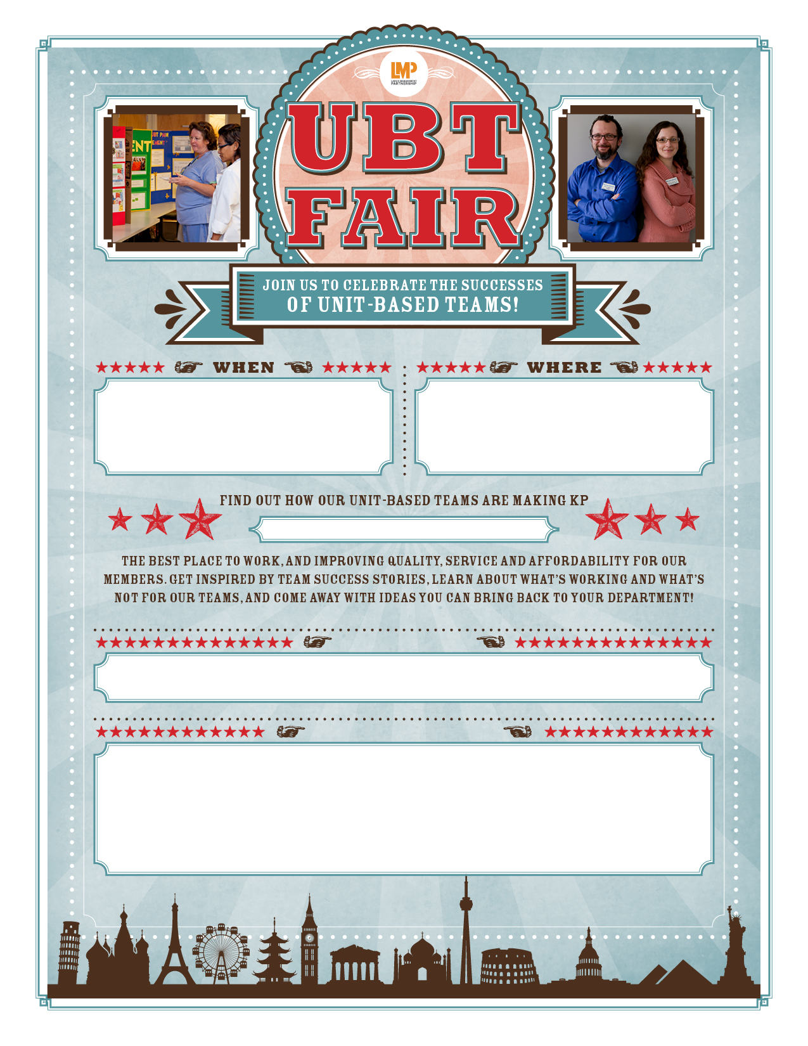

**[Insert Day of Week]  
[Insert Date of month]**

**[Insert Time of day]**

**[Insert features about events such as food, displays, contests, etc.]**

**[Insert Facility, Location, Floor]**