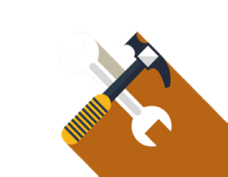 | tool  Data Collection Planning Tool
PURPOSE
This tool helps a team determine what they will measure, how they will measure it, and who will collect the data. After using this tool to collect data, the UBT will be able to determine whether the change was effective and whether there were barriers that need to be removed.
When to Use
Use this tool after you have identified what actions you are going to take to test for process improvement.
Who Uses
UBT teams.
How to Use
Make tally marks for each day to get simple data that will help you determine whether your actions are making a positive change.

When planning data collection, the team needs to ask itself these questions:
[  ] | What will we measure?
[  ] | What are the definitions?
[  ] | Who will collect the data?
[  ] | How and when will the data be collected, for how long, and how often?
[  ] | Do we have a process for collecting and entering the data?
The best people to create and test a data collection tool are frontline staff:
- Test tool ideas on paper and do so quickly before formalizing the tool.
- Collect only relevant data you can use.
- Make sure your data collection tool includes a definition of measures and information as to what is and is not included, and ensure it simplifies the information to be entered.

Example
