ACTIVITY: Co-Lead Action Planning Worksheet
UBT Name:

Management Co-Lead:

Labor Co-Lead:

Use this worksheet to capture working agreements between co-leads in the following areas:

Co-Lead Working Styles:

- Communication preferences (in person, email, phone, etc.)

- What agreements do we have about handling conflict?

ACTIVITY: Co-Lead Action Planning Worksheet (continued)
3. Where would you appreciate support?

Team Charter and Other Working Agreements:

- Do we want to use a charter?

- What might be in the charter? Do we want to use the standard charter template tool for our charter?

- If we have a charter, are there gaps in it?

ACTIVITY: Co-Lead Action Planning Worksheet (continued)
Planning for Meetings:

When do we need to meet to plan, who is creating the agenda, etc.?

Opening Meetings:

Who will facilitate the opening, what will we need to say?

Running Meetings:

Who facilitates which topics, what do we want?

ACTIVITY: Co-Lead Action Planning Worksheet (continued)

Closing Meetings:

What actions do we take to close our meetings?

Other Issues or Concerns for Sponsors to Address:

Agenda for UBT Kick-off Meeting

Purpose
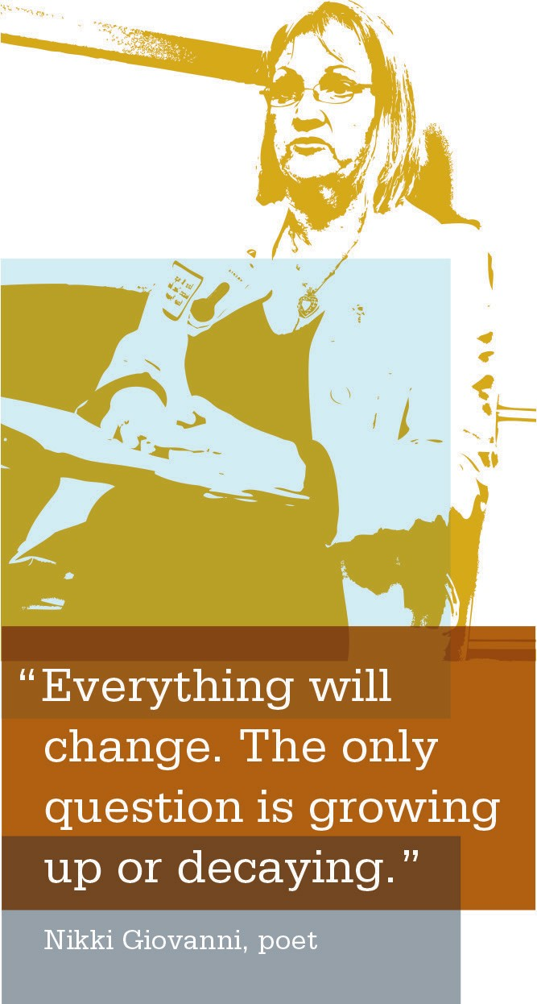
The UBT kick-off meeting sets the stage for future out- comes and working agreements for the UBT. A kick-off meeting that is well organized, with a clearly defined agenda and outcomes, will help your team members feel confident that future meetings will be efficient. The sample agenda provides you with an idea of what might be covered for the best outcomes.

How to Use
Use the sample agenda on the following page as a tool to ensure you are covering the necessary steps for a successful kick-off meeting.

Checklist for a Successful Kick-off Meeting
[ | ] | Review the sample agenda. Create your own version making any necessary modifications.
[ | ] | Distribute a copy of the agenda to your team prior to your meeting.
[ | ] | Meet with your co-lead to get clarity on who has what role during the kick-off.
[ | ] | Prepare any materials that need to be presented to UBT members.
[ | ] | Determine whether the sponsor needs to be present at the kick-off meeting. If so, create space at the beginning of the agenda for the sponsor to set the context of the UBT work for the organization.

